### **RELEASE ENGINEERING WORK FLOW SOP**

#### **Document Information**

* **Document Title: RELEASE ENGINEERING WORK FLOW**
* **Version:1.1**
* **Prepared By: Release Engineering Team**

Table of Contents

**RELEASE ENGINEERING WORK FLOW SOP** 1

**1. Introduction** 2

1.1 Purpose of Document 2

**2. Release Engineering Team Roles** 2

**2. 1Release Engineering Team Tools** 2

**2. 2 Jenkins Jobs used by Release Engineering Team** 2

**3. Inflight Release Application** 2

**3.1 Blackout Dates** 3

**4. Daily Task of Release Engineering Team** 5

**4.1List of repo’s Jenkins Job** 6

4.2 Compare Branches 6

4.3 Create Cloudbees Snapshot 7

5.0 Creating the branch(Weekly Release Number ) 8

5.1 Branch Permissions 10

**6. Inflight release application backup** 12

7.1 Staging Deployment 13

7.3 Production Deployment Preparation 13

8.0 Compare Release Confluence Page 14

(List of repo’s & Compare branches daily jobs update in confluence page) 14

150 - Compare release code in inflight release with master branch - Release Management (New) - Confluence (trinet-devops.com) 14

9. Post Deployment Code Merge (Merge to master) 14

10. Pull Request Merge 18

11. Release Engineering Daily URL’S 23

# **1. Introduction**

## **1.1 Purpose of Document**

The purpose of this document is to provide a comprehensive guide for the Release Engineering Team's daily activities. It outlines detailed procedures for managing inflight page updates, documenting comments, and handling STG1/2 and production change requests. The document also includes instructions for updating and managing change requests to ensure smooth deployments and guidelines for reviewing, approving, and merging pull requests.

# **2. Release Engineering Team Roles**

Release Engineering team takes care of all the releases planned for everyday updates the change plan for STG1/2, PROD, work on pull requests PR from developers when they face any issue, after prod deployment merge to master is also taken care by RE team.

Inflight page comments and mail chain update, Inflight page backup, Change plan update in ServiceNow.

# **2. 1Release Engineering Team Tools**

Inflight page application, ServiceNow, Confluence, Jenkins, Cloud bees, Stash (Bitbucket), GitHub.

# **2. 2 Jenkins Jobs used by Release Engineering Team**

* List-of-repositories

[List_of_repositories_in_a_release [Tools] [Jenkins] (trinet.internal)](https://jenkins.engtools01.trinet.internal/job/Tools/job/List_of_repositories_in_a_release/)

* Compare-branches

[compare-branches [Tools] [Jenkins] (trinet.internal)](https://jenkins.engtools01.trinet.internal/job/Tools/job/compare-branches/)

* Cloud bees snapshot

[Create-Cloudbees-Snapshot-Platform(PROD) [ReleaseEngineering] [Jenkins] (trinet.internal)](https://jenkins.engtools01.trinet.internal/view/Release%20Tools/job/ReleaseEngineering/job/Create-Cloudbees-Snapshot-Platform(PROD)/)

* Merging activity

[MergeBranch [ReleaseEngineering » BranchAffairs] [Jenkins] (trinet.internal)](https://jenkins.engtools01.trinet.internal/view/Release%20Tools/job/ReleaseEngineering/job/BranchAffairs/job/MergeBranch/)

# **3. Inflight Release Application**

Overview

Inflight release application is an internal tool used to manage the current releases. This replaces the [confluence page](https://confluence.trinet-devops.com/pages/viewpage.action?spaceKey=RM1&title=Inflight+and+Upcoming+off+cycle+Releases) currently used by the agile teams. This user document explains how to use this application.

Application URL

<https://inflight.engtools01.trinet.internal/view/>

Main Menu

After you land on the inflight page you can click on the hamburger menu on the top left side of the page to expand the menu options.

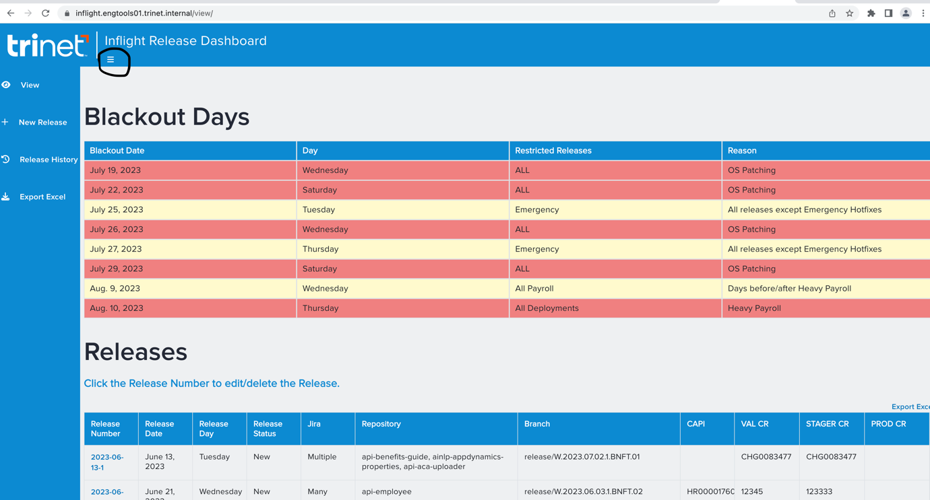

# **3.1 Blackout Dates**

View Menu

* When you click on the view page, you will see the view page with blackout days listed for the next four weeks on top of the page. High severe blackout dates are color coded in red and less severe blackout dates are color coded in yellow. **You cannot enter releases on high severe blackout dates,** for less severe blackout dates you should be able to add releases with a warning message. If any release has to go on a high severe blackout date,  please reach out to Release Engineering team([eng.release@trinet.com](mailto:eng.release@trinet.com))

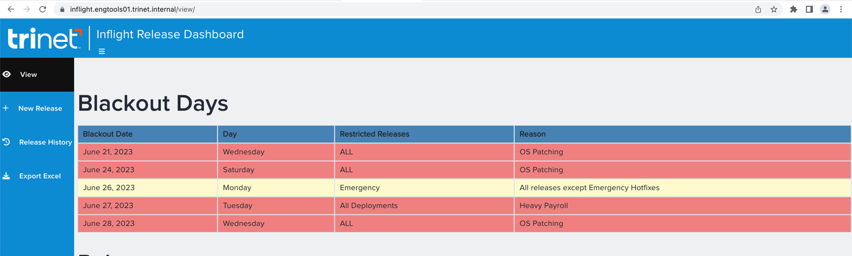

* Below the Blackout days table, current releases overview is provided. These  releases are in  progress in the SDLC environments and getting ready for the production deployments.

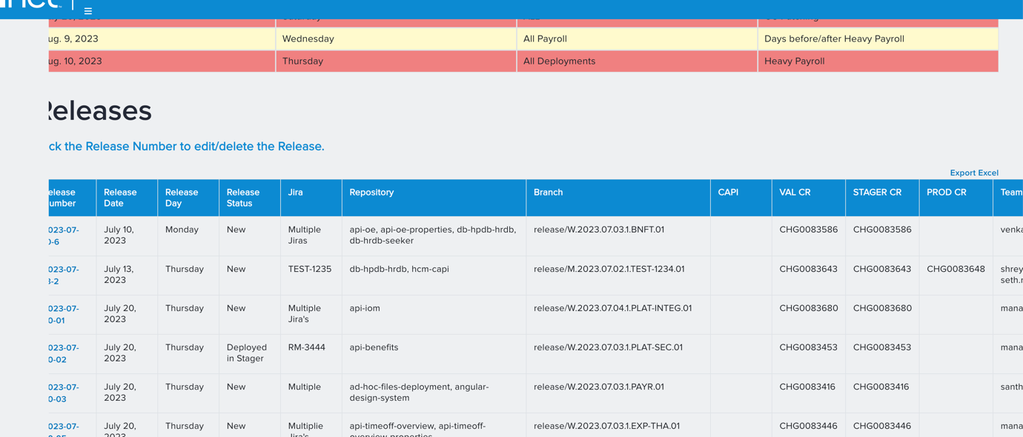

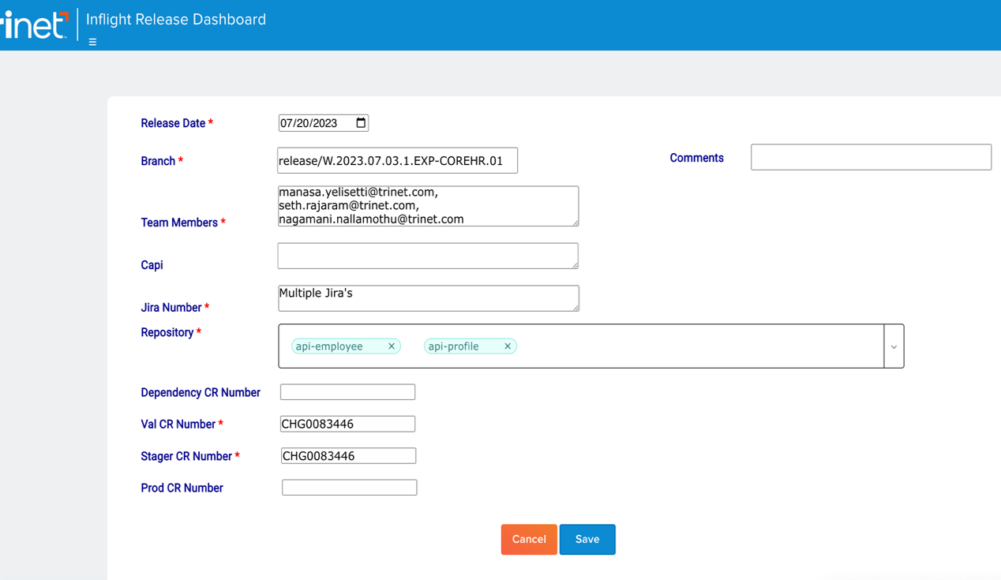

* Release Date: Mandatory field and it only accepts current or future date.
* Branch : The branch name is also a mandatory field which does not allow you to enter a release branch which already exists in current releases.
* Team Members: Mandatory field which is expandable when enter is clicked. It accepts comma delimited email addresses of all the team members associated with the release. It check for a format of ($firstname.$lastname@[trinet.com](http://trinet.com/))
* CAPI: Optional field, this is expandable when enter is clicked, which accepts a comma-delimited list of CAPIs.
* Jira Number:  Optional field, this is expandable when enter is clicked, which accepts a comma-delimited list of Jira numbers.
* Repository:  Mandatory field, where you can search and select the repositories from the dropdown.

Release Status(update of inflight page comments)

* The release status will be updated based on the stg1/atg2/prod cr statuses.
* **Only Release team should update the status of the stg1/stg2/prod CRs after verifying the deployments.**
* STG1 CR status applied:  Deployed in STG1
* STG2 CR status applied: Deployed in STG2
* PROD CR status applied:  Initial Approval, CCB Approved, Deployed in PROD

# **4. Daily Task of Release Engineering Team**

* Check inflight page releases for that day and check if any production CR’s are planned for that day and check CCB page and inflight page releases are same or not.
* Also check the planned production CR’s in service now whether they are in implementation state or not.
* If in case any of these checks mail reply to mail saying this is missing.
* Inflight page all releases planned for that day should be checked for list of repos and compare branches jobs and we should give a heads-up priorly for any missing repo’s and sync issues to developers.
* We should update the list of repos and compare branches in the below confluence page by creating a new confluence page daily.
* [150 - Compare release code in inflight release with master branch - Release Management (New) - Confluence (trinet-devops.com)](https://confluence.trinet-devops.com/pages/viewpage.action?spaceKey=RM1&title=150+-+Compare+release+code+in+inflight+release+with+master+branch)
* Updating the STG1/2 change plan when we get request from developer:
* When we get a stagger change plan update request firstly need to check whether the CR is mentioned in inflight page or not.

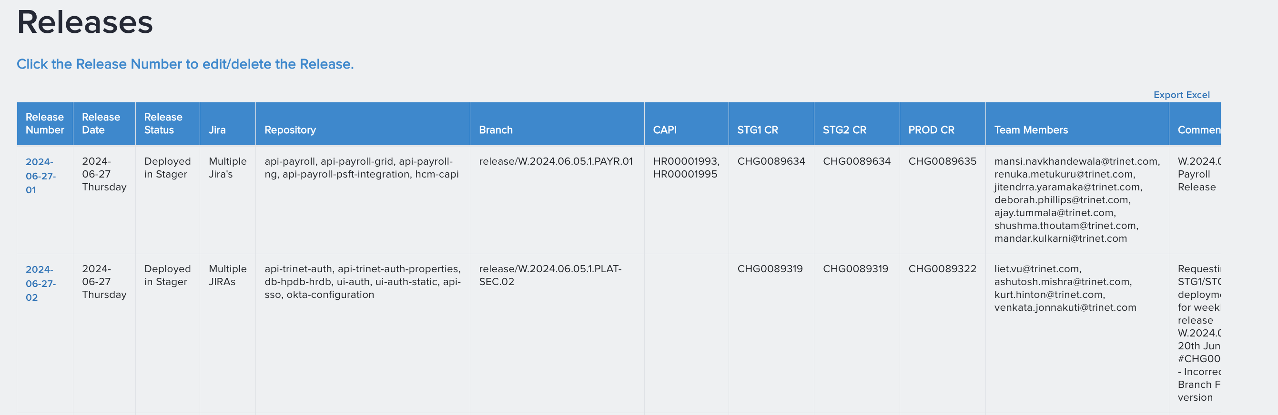

* Firstly, we need to check in inflight page for repos and branch name and mentioned CR and then we should go to Jenkins job list of repos, compare branches, cloudbees snapshot job

# **4.1 List of repo’s Jenkins Job**

1.Go to this Jenkins Job - [List_of_repositories_in_a_release [Tools] [Jenkins] (trinet.internal)](https://jenkins.engtools01.trinet.internal/job/Tools/job/List_of_repositories_in_a_release/)

2. Click on "**Build with Parameters**"

To run this job we need to give parameter as branch name ex:release/W.2024.06.05.1.PAYR.01 from inflight page after running the job we get output and we should check for the repos.

* 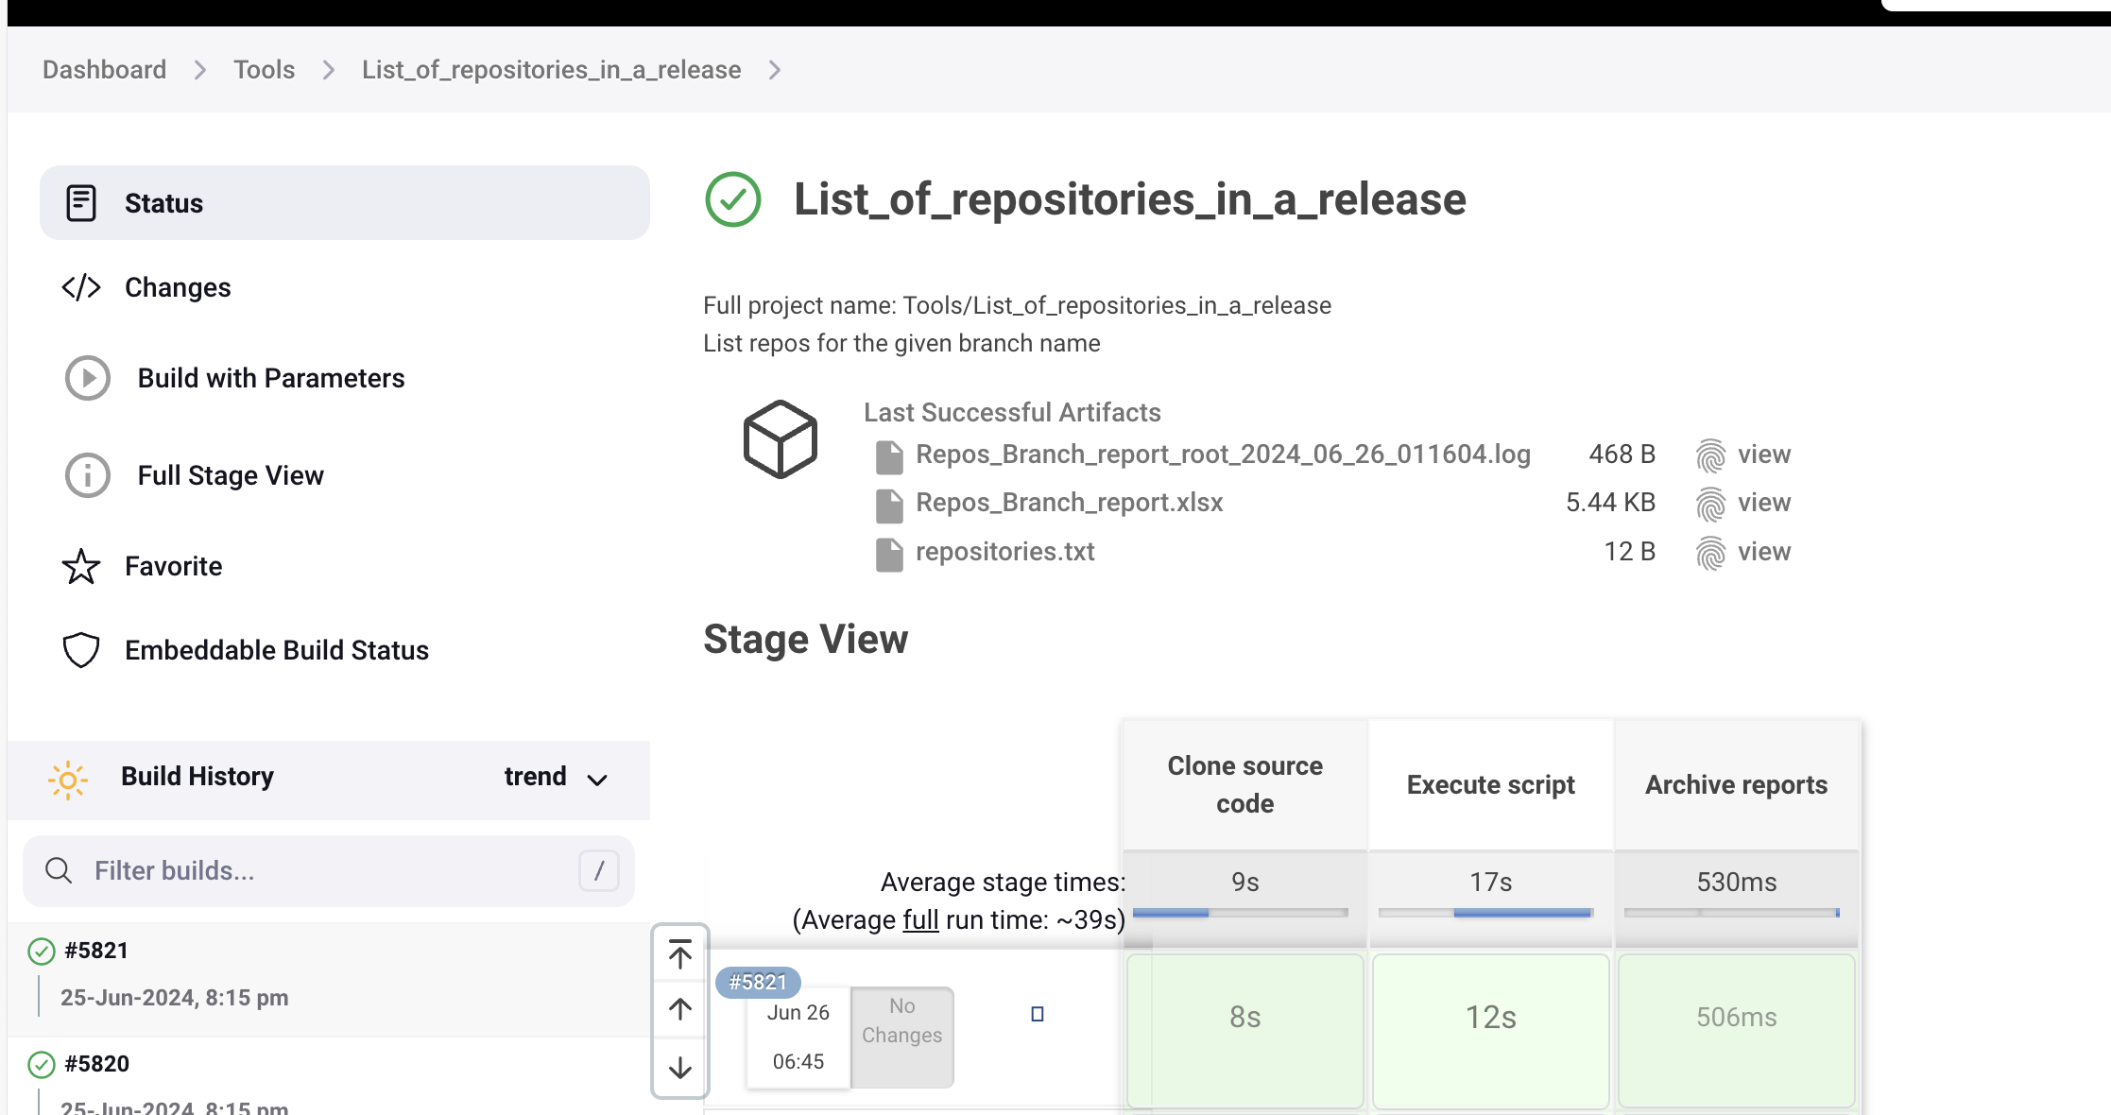

The inflight page mentioned repo’s and repository.txt output should be same if not we should revert back to the developer.

## **4.2 Compare Branches**

1.Go to this Jenkins Job - **[compare-branches [Tools] [Jenkins] (trinet.internal)](https://jenkins.engtools01.trinet.internal/view/Release%20Tools/job/Tools/job/compare-branches/)**

2. Click on "**Build with Parameters**" as shown in below screenshot.

To run compare branches job we should mention repo’s list and branch name and run the job, we get output as repo’s in sync or not.

Ex: repo’s: api-payroll, api-payroll-grid, api-payroll-ng, api-payroll-psft-integration, hcm-capi, branch name: release/W.2024.06.05.1.PAYR.01

* 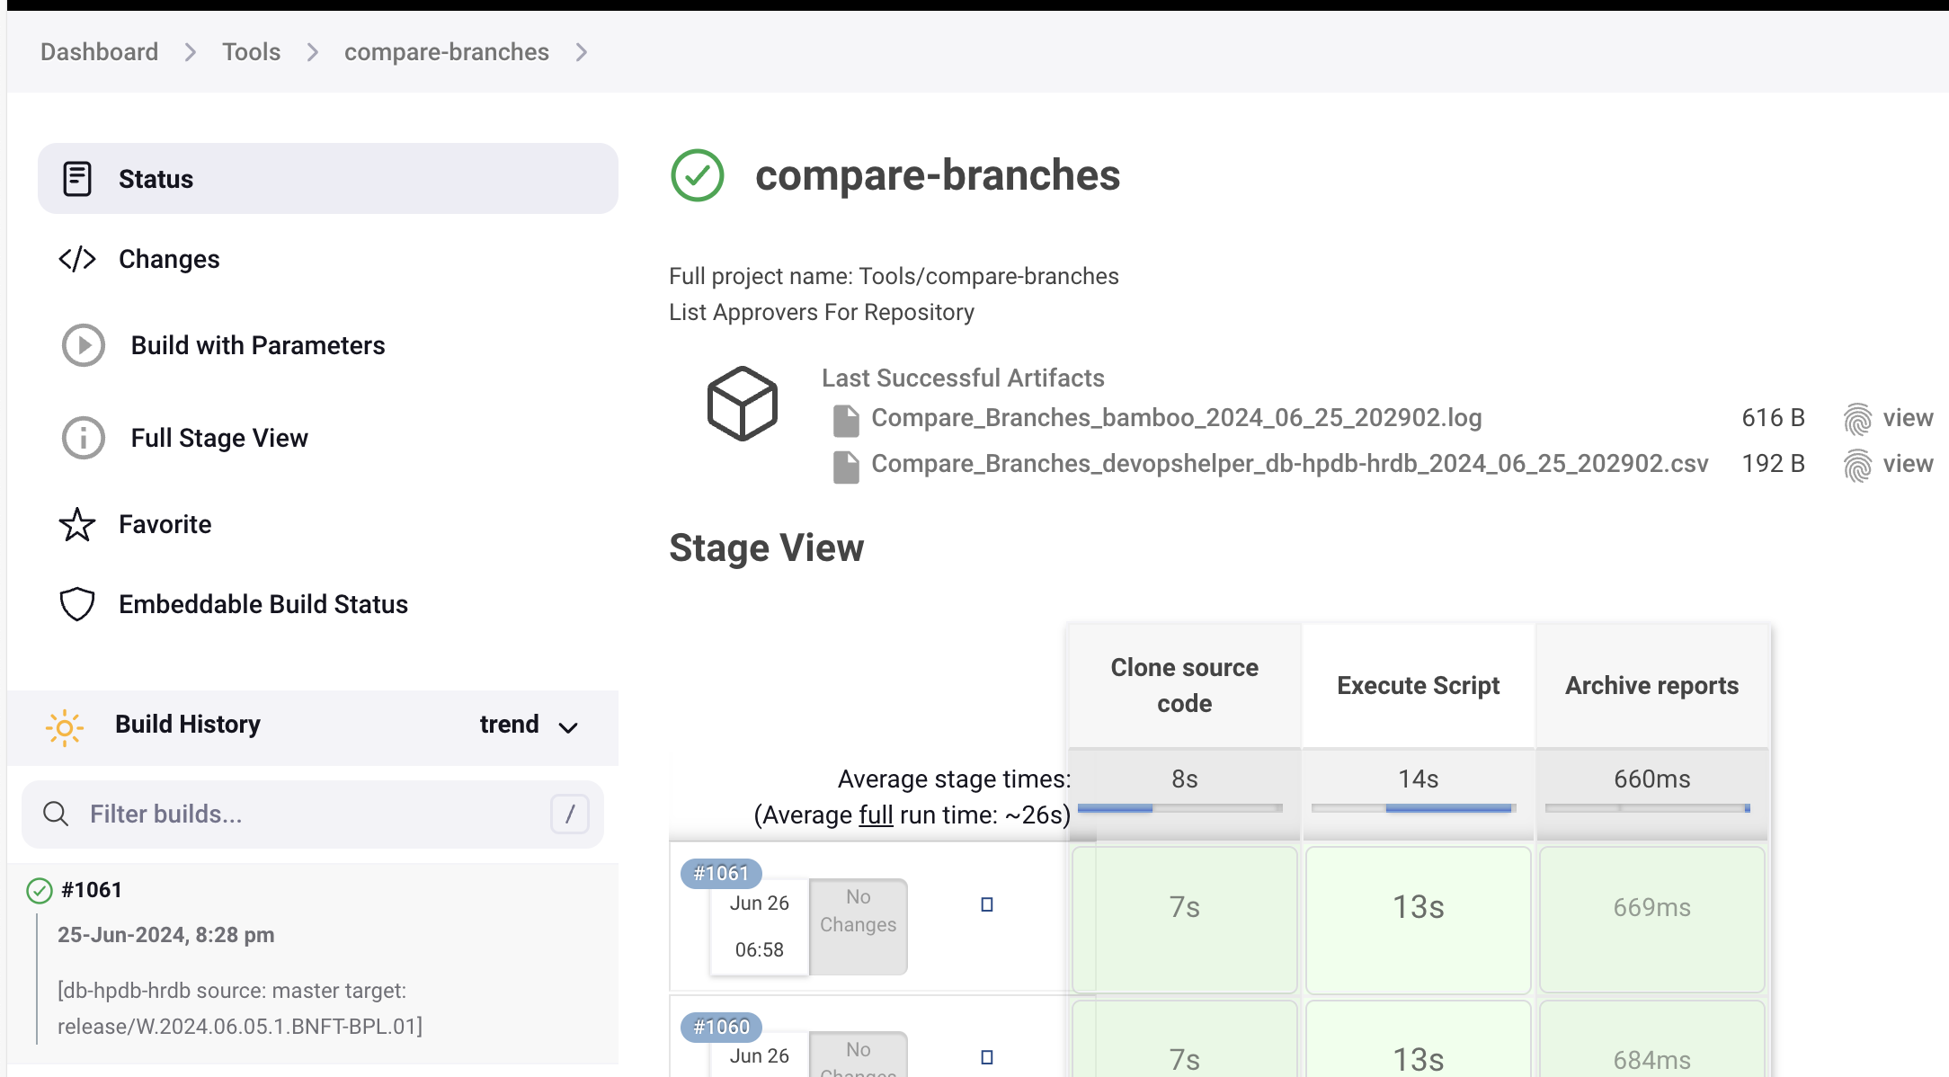

In the output we can check the sync of master if everything goes well then we can go-ahead for next cloudbees snapshot job if not we should give reply back to developer saying some sync issue is missing.

## **4.3 Create Cloudbees Snapshot**

* [Create-Cloudbees-Snapshot-Platform(PROD) [ReleaseEngineering] [Jenkins] (trinet.internal)](https://jenkins.engtools01.trinet.internal/view/Release%20Tools/job/ReleaseEngineering/job/Create-Cloudbees-Snapshot-Platform(PROD)/)

To run this job we should give repo’s list and branch name in the parameters section and run the job so that we will get the steps to run the cloud bees job for AD team so that we can give the change plan for the team to go ahead.

Ex: repo’s: api-payroll, api-payroll-grid, api-payroll-ng, api-payroll-psft-integration, hcm-capi, branch name: release/W.2024.06.05.1.PAYR.01

* 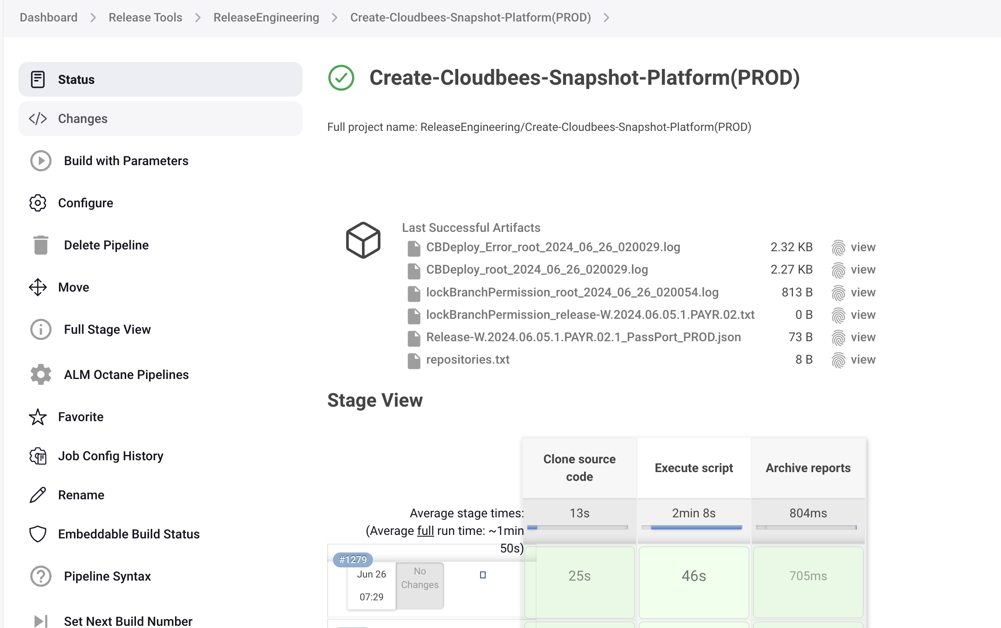

After successful job ruining we will get the change plan and this we need to update it in ServiceNow, so we need to go to navigate to service now and check the CR

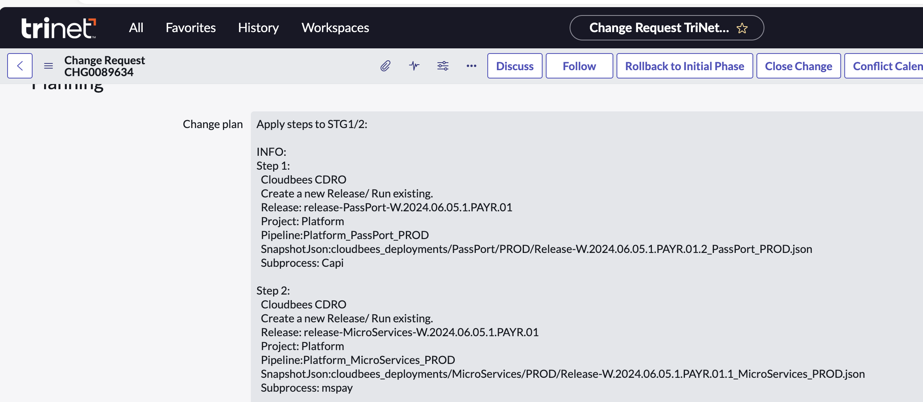

## **5.0 Creating the branch(Weekly Release Number )**

Releaseinfo.yml

* Login to Jenkins: [Dashboard [Jenkins] (trinet.internal)](https://jenkins.engtools01.trinet.internal/)

URL: [Dashboard [Jenkins] (trinet.internal)](https://jenkins.engtools01.trinet.internal/)

* Go to tools folder:
* Click on Create-Branch-Weekly-with-Weekly-seq-num Job

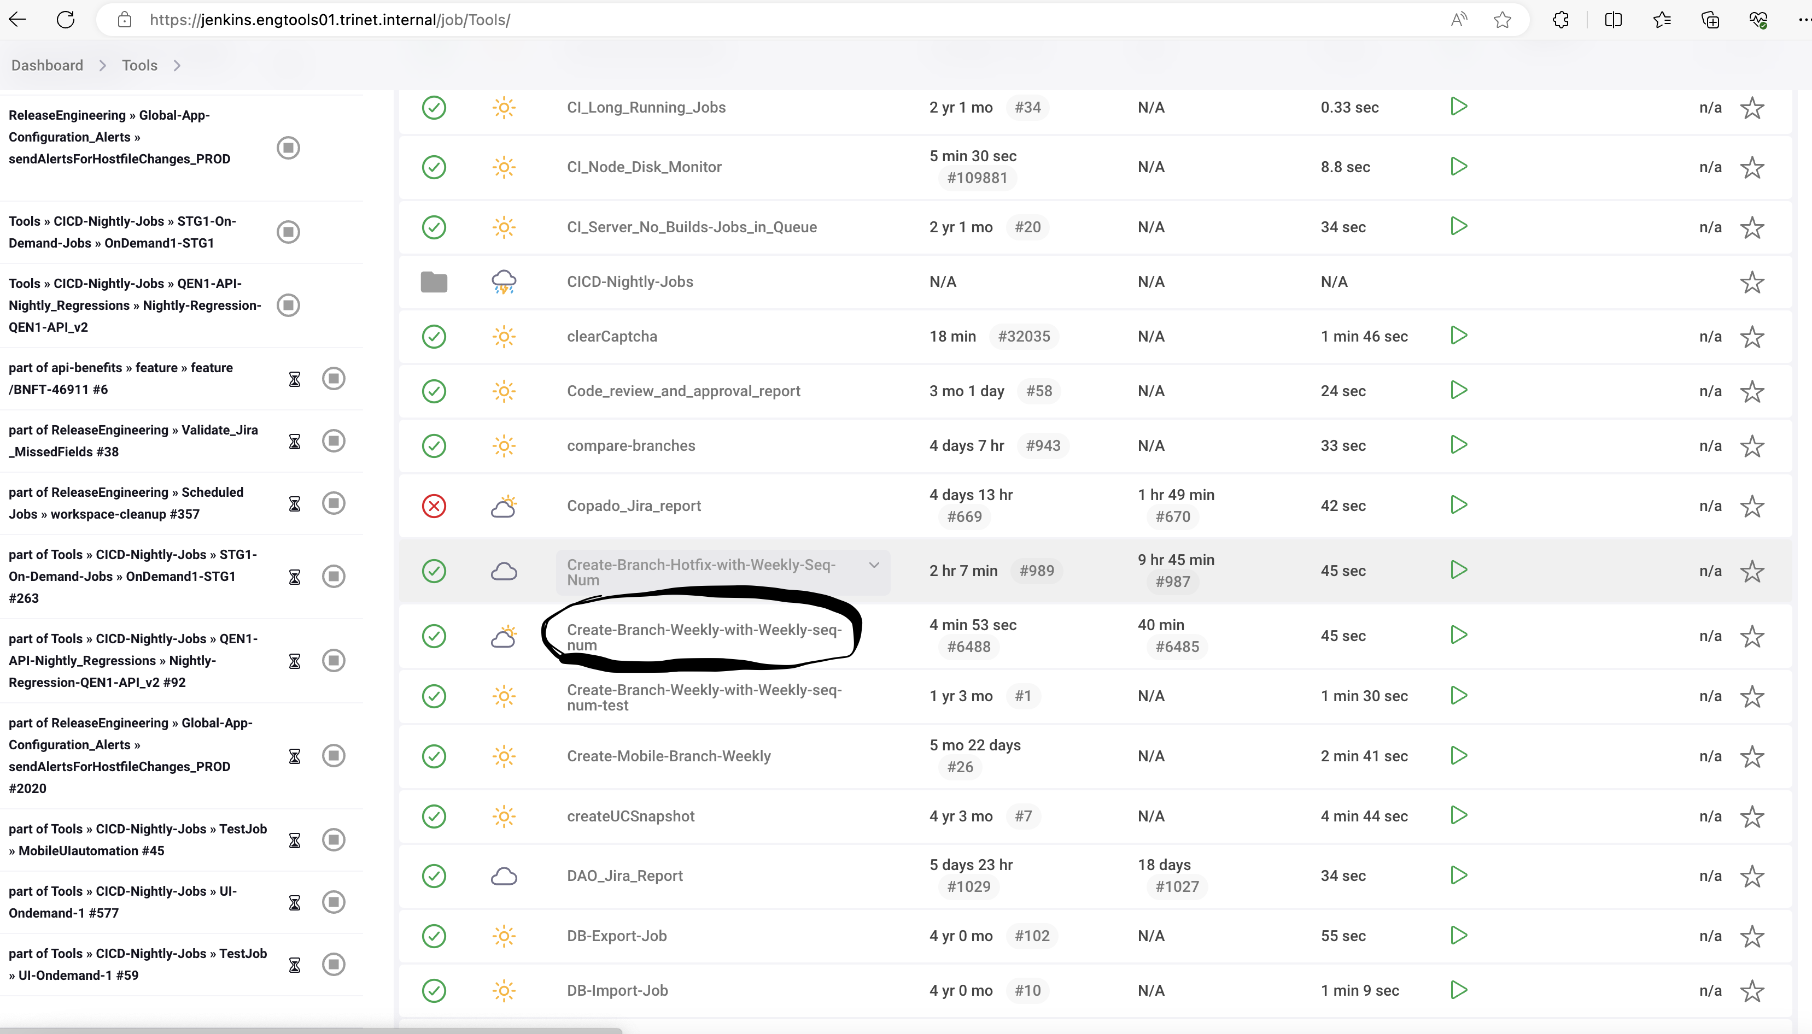

* Click on Build with Parameter
* Select or filter repository name
* Click source branch type
* Select or filter source branch
* select weekly release team, weekly release iteration & weekly release version.

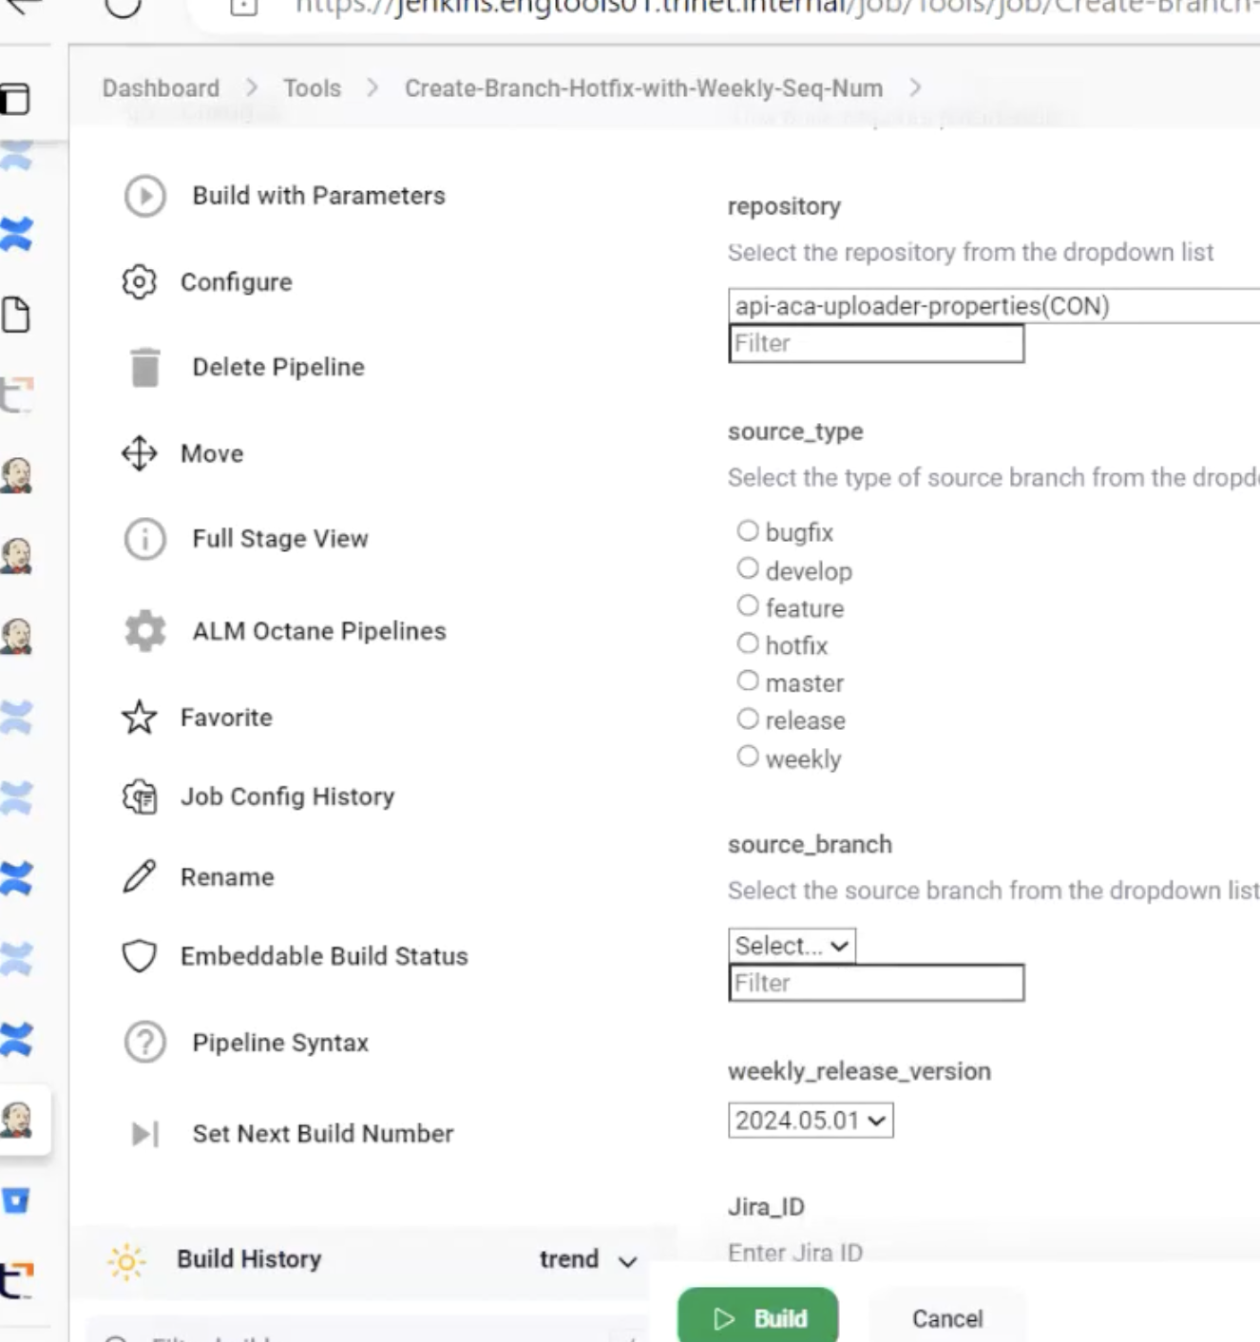

* Based on the values selected, the target branch name is auto created and shown in the dropdown.
* Validate the target branch formed and click on the build button.
* There will be a green colour check mark near the build number if the branch is created
* There will be a red colour check mark near the build number if the branch is NOT created

## **5.1 Branch Permissions**

* Whenever We are creating branches, we need to set branch permissions as per domain group. AD Domain group will create for certain persons who are needed the branch permissions as per the Teams. Branch Permissions is to set Permits that who can take actions on that particular branch. This includes
* Reviewing
* Deleting the Branch
* Changes to that Branch without request
* PR Approval
* If Anyone Try to merge Pull Request, the branch Permissions will not allowed and shown error as long as you’re not a part of that AD Domain Group.
* Jenkins Job will create the Branches and Branch permissions and all but If any 100 error is there, RE Team will check the error and resolve the issue and they will Remove the branch permissions.

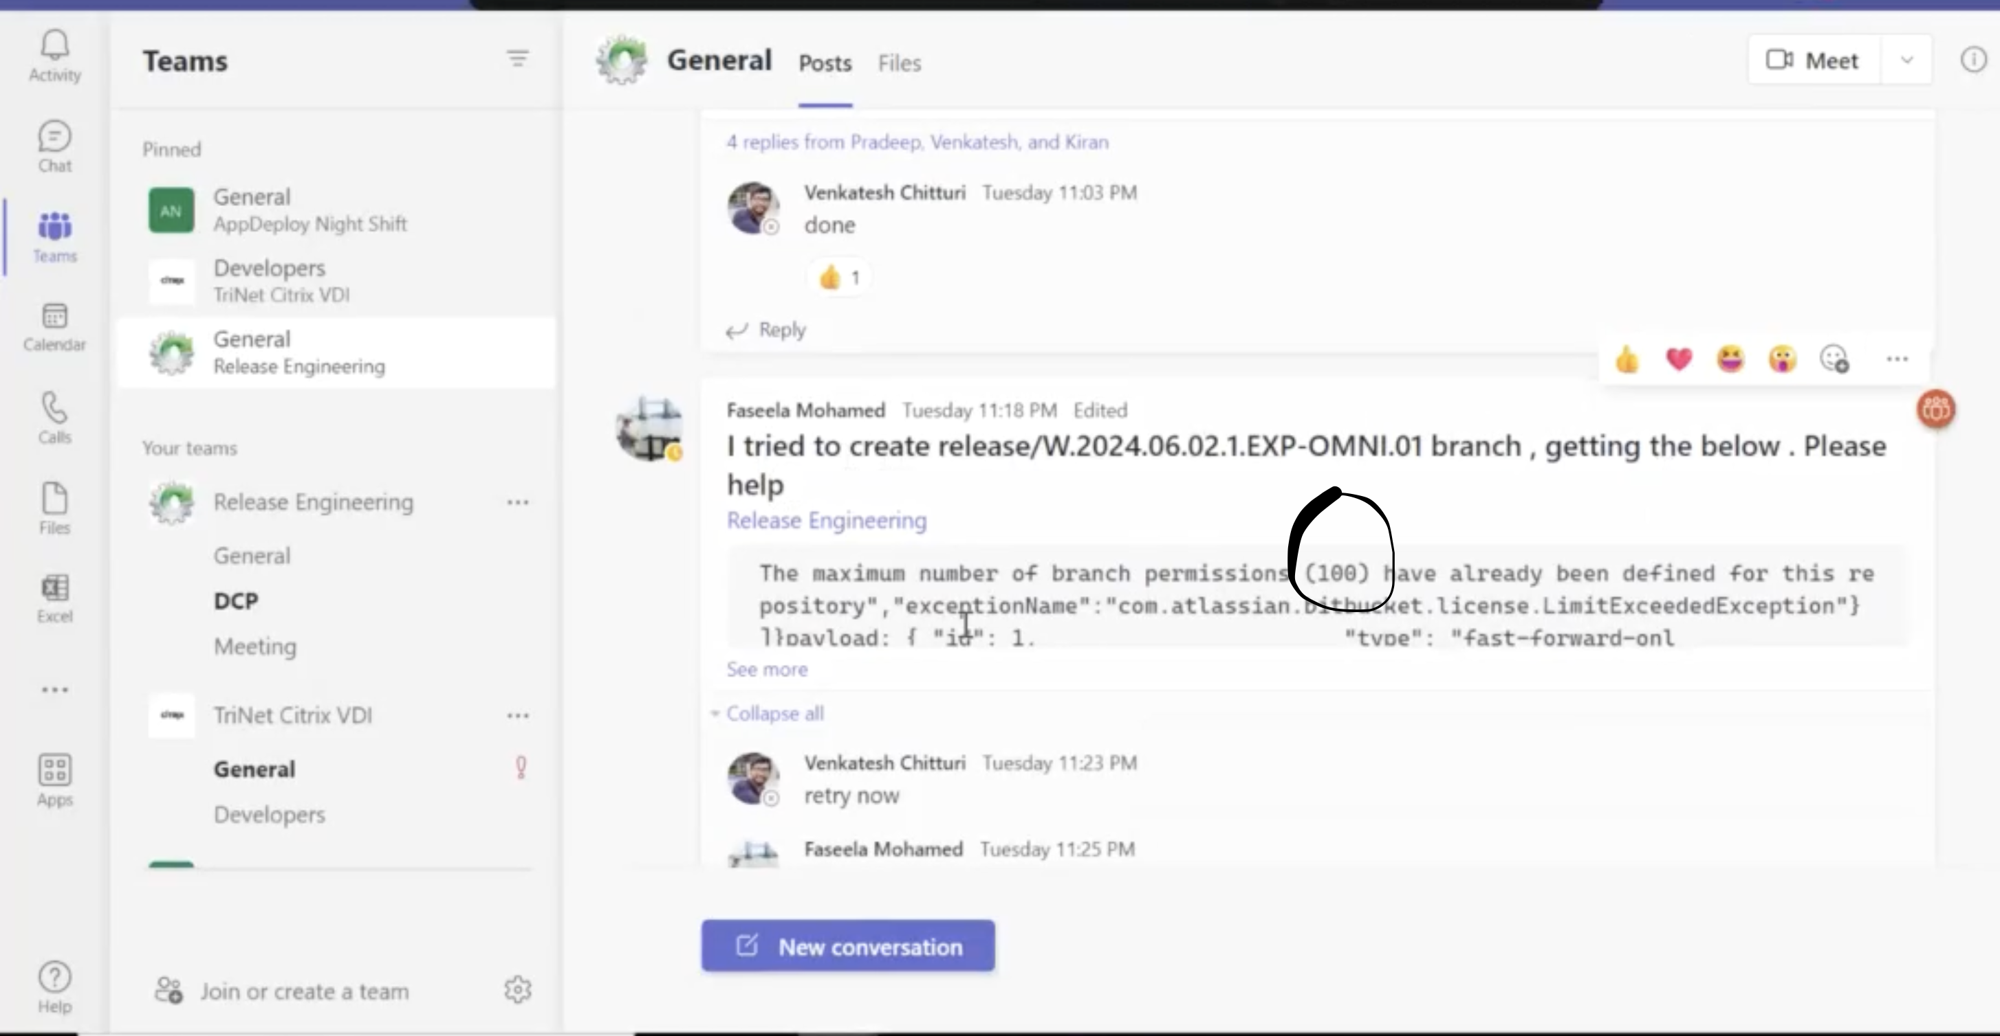

* Bitbucket login: [Browse Release Management / cloudbees_deployments - Stash (trinet-devops.com)](https://stash.trinet-devops.com/projects/RM/repos/cloudbees_deployments/browse)
* Release Management > Cloudbees deployments > search for branches
* Select Branch Permissions

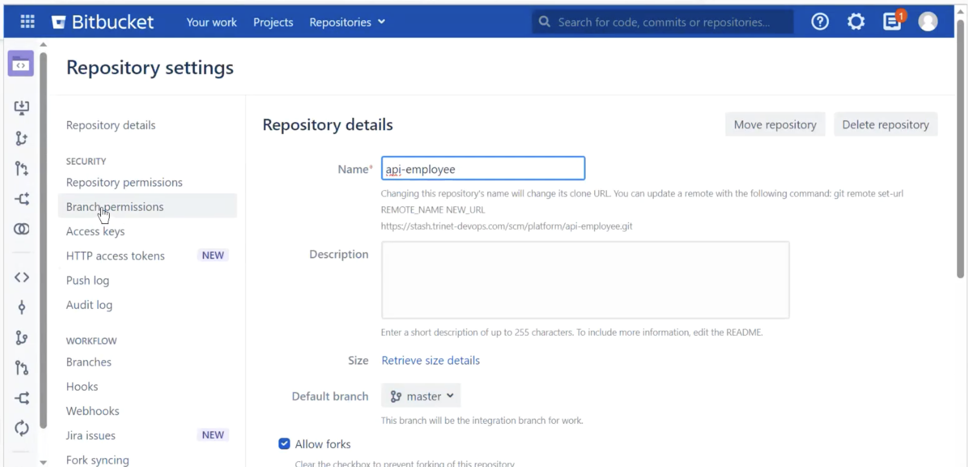

* If Any older branches is there, then remove those older branches then it will Remove the Branch permissions also as shown in below

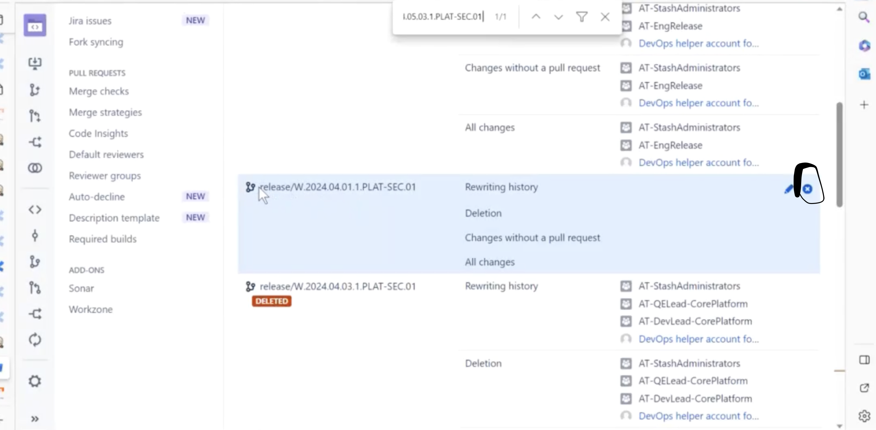

* Remove Branch permissions

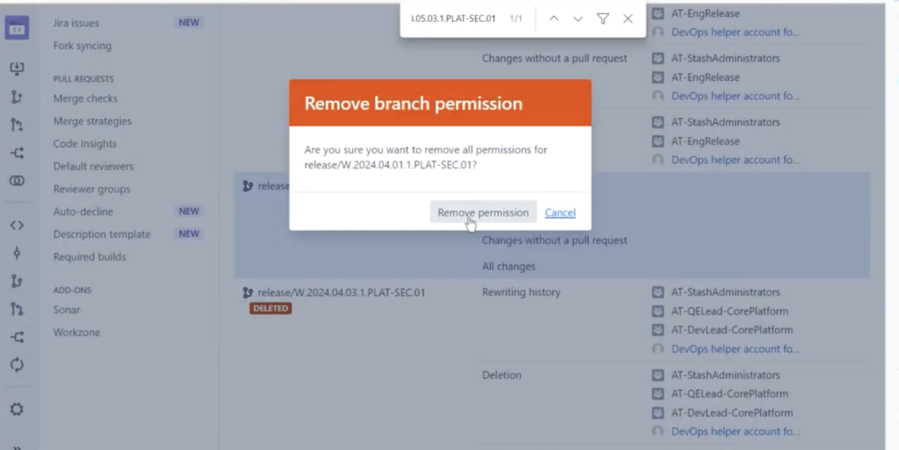

* DON’T DELETE CURRENT BRANCHES or NOT DEPLOYED BRANCHES.
* After completion of removing Branch Permissions then confirm with them.

# **6. Inflight release application backup**

* We have an backup page to which we need to upload the backup sheet on daily basis
* The below is the link for backup page:

[120 - Inflight release page backup - Release Management (New) - Confluence (trinet-devops.com)](https://confluence.trinet-devops.com/pages/viewpage.action?spaceKey=RM1&title=120+-+Inflight+release+page+backup)

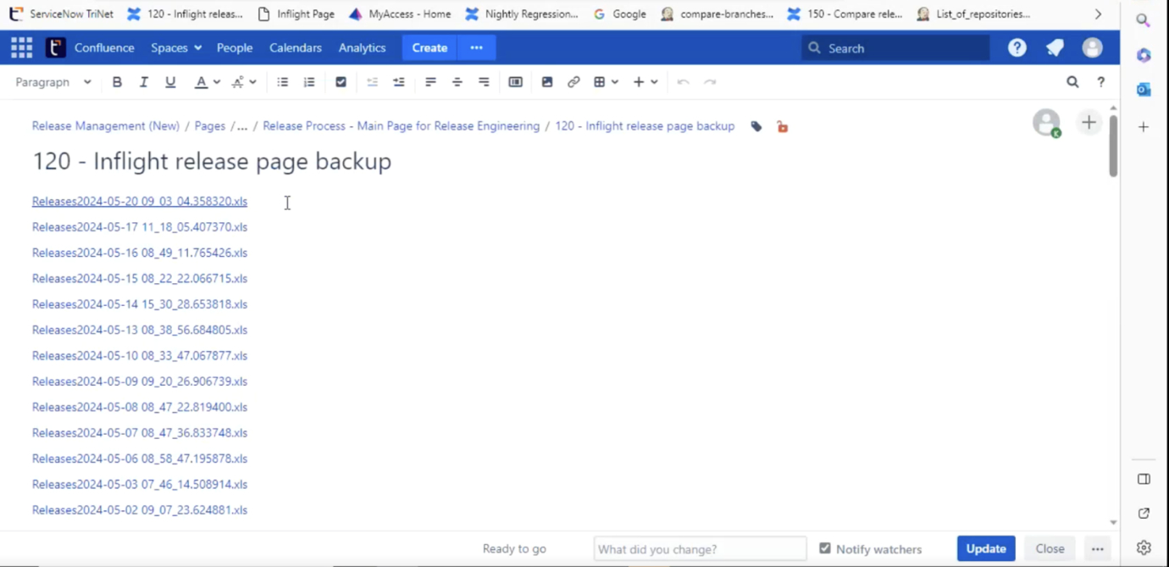

* The below is the link for backup page: We need to login to the backup page and in the page we need to upload the sheet from our local machine which we have downloaded earlier, In generally we need to update this backup page in between 2:00 to 3:00pm IST

## **7.1 Staging Deployment**

* Check the mails and the mentioned CR developer requests for deployment in STG1/STG2.
* Then check in inflight page whether it is included in page or not if not revert back to developer.
* Then check the repos mentioned in email and inflight dashboard matching or not if not reply back to developer about missing repos.
* If repos in mail and inflight page are same we will go to list of repos Jenkins job and run the job.
* After running the job we need to check the list of repos output of anything missing we need to update to developers about missing repos list. If no repo missing then we can run compare branch job
* Run compare branch jobs, if gives repo sync output if any repo is not in sync we need to update to developer that certain job is not in sync.
* Then developers pull the changes from different teams and merge the PR.
* After merging of PR, If repos are in sync, then we can deploy the CR to STG.
* After the CR gets approved then we need to ask AD team to approve the CR
* After Stager deployment is done we need to update it in inflight page as Deployed to stager, we can edit this only for the current day till 11:59pm of that particular day.

## **7.3 Production Deployment Preparation**

1) PROD CR update - Do not run CB job, we must copy as it is from STG1/2 & update PROD CR.

* Copy change plan from STG1/2 CR and update in prod CR.
* Check if the start time is 21 i.e.., 9 PM PST.
* Check if Jira report attached to PROD CR & all Jira’s in the report are done/Ready to release state (not STG report

2) STG1/2 Requests - Do not run directly CB job, it locks branch permissions.

i) Run list of repos, Sync issues with master & then common repo sync issue. If all good only run CB job & update STG1/2 CR.

## **8.0 Compare Release Confluence Page**

(List of repo’s & Compare branches daily jobs update in confluence page)

[150 - Compare release code in inflight release with master branch - Release Management (New) - Confluence (trinet-devops.com)](https://confluence.trinet-devops.com/display/RM1/150+-+Compare+release+code+in+inflight+release+with+master+branch)

* Daily task release engineering team need to perform
* We create a new child page daily with reference to that day inflight page releases and
* Here we check all the releases
* We run list of repos and common branches jenkins job for each individual CR mentioned in that release page.
* If we get any repo missing or any repo is not in sync with master we need to update the same through mail to developer saying that the release when u have planned in particular date is not in sync please check and update or else particular repo is missing please check the repos add repo or delete repo or else update.

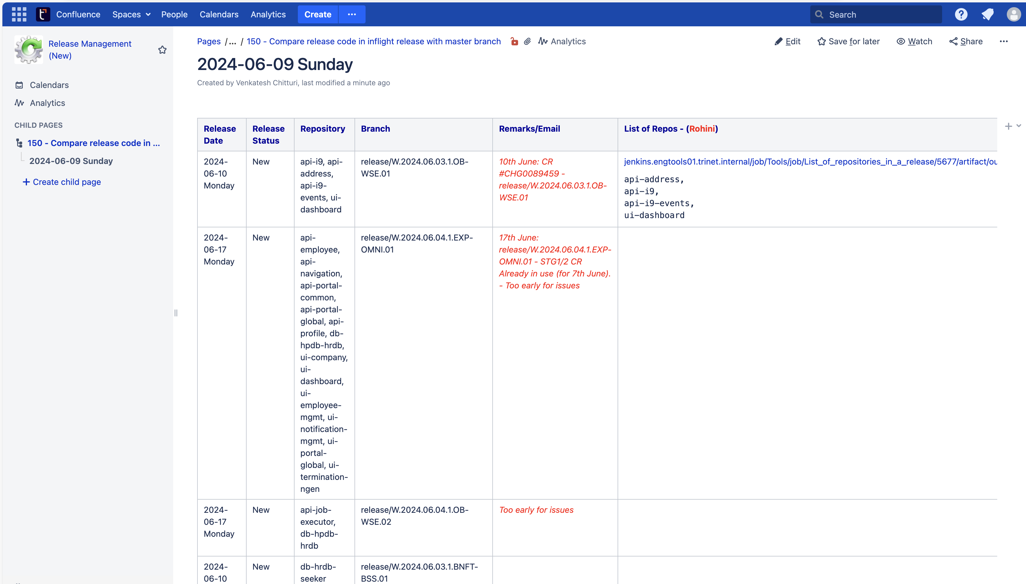

## **9. Post Deployment Code Merge (Merge to master)**

Once App Deploy Team confirmed the production deployment is done successfully, then we RE Team need to merge those release branches with master. The process will show below steps.

* Once CR is deployed in prod then developer asks us for merging to master
* We need to check inflight page for the prod deployed CR which are to be planned for merging

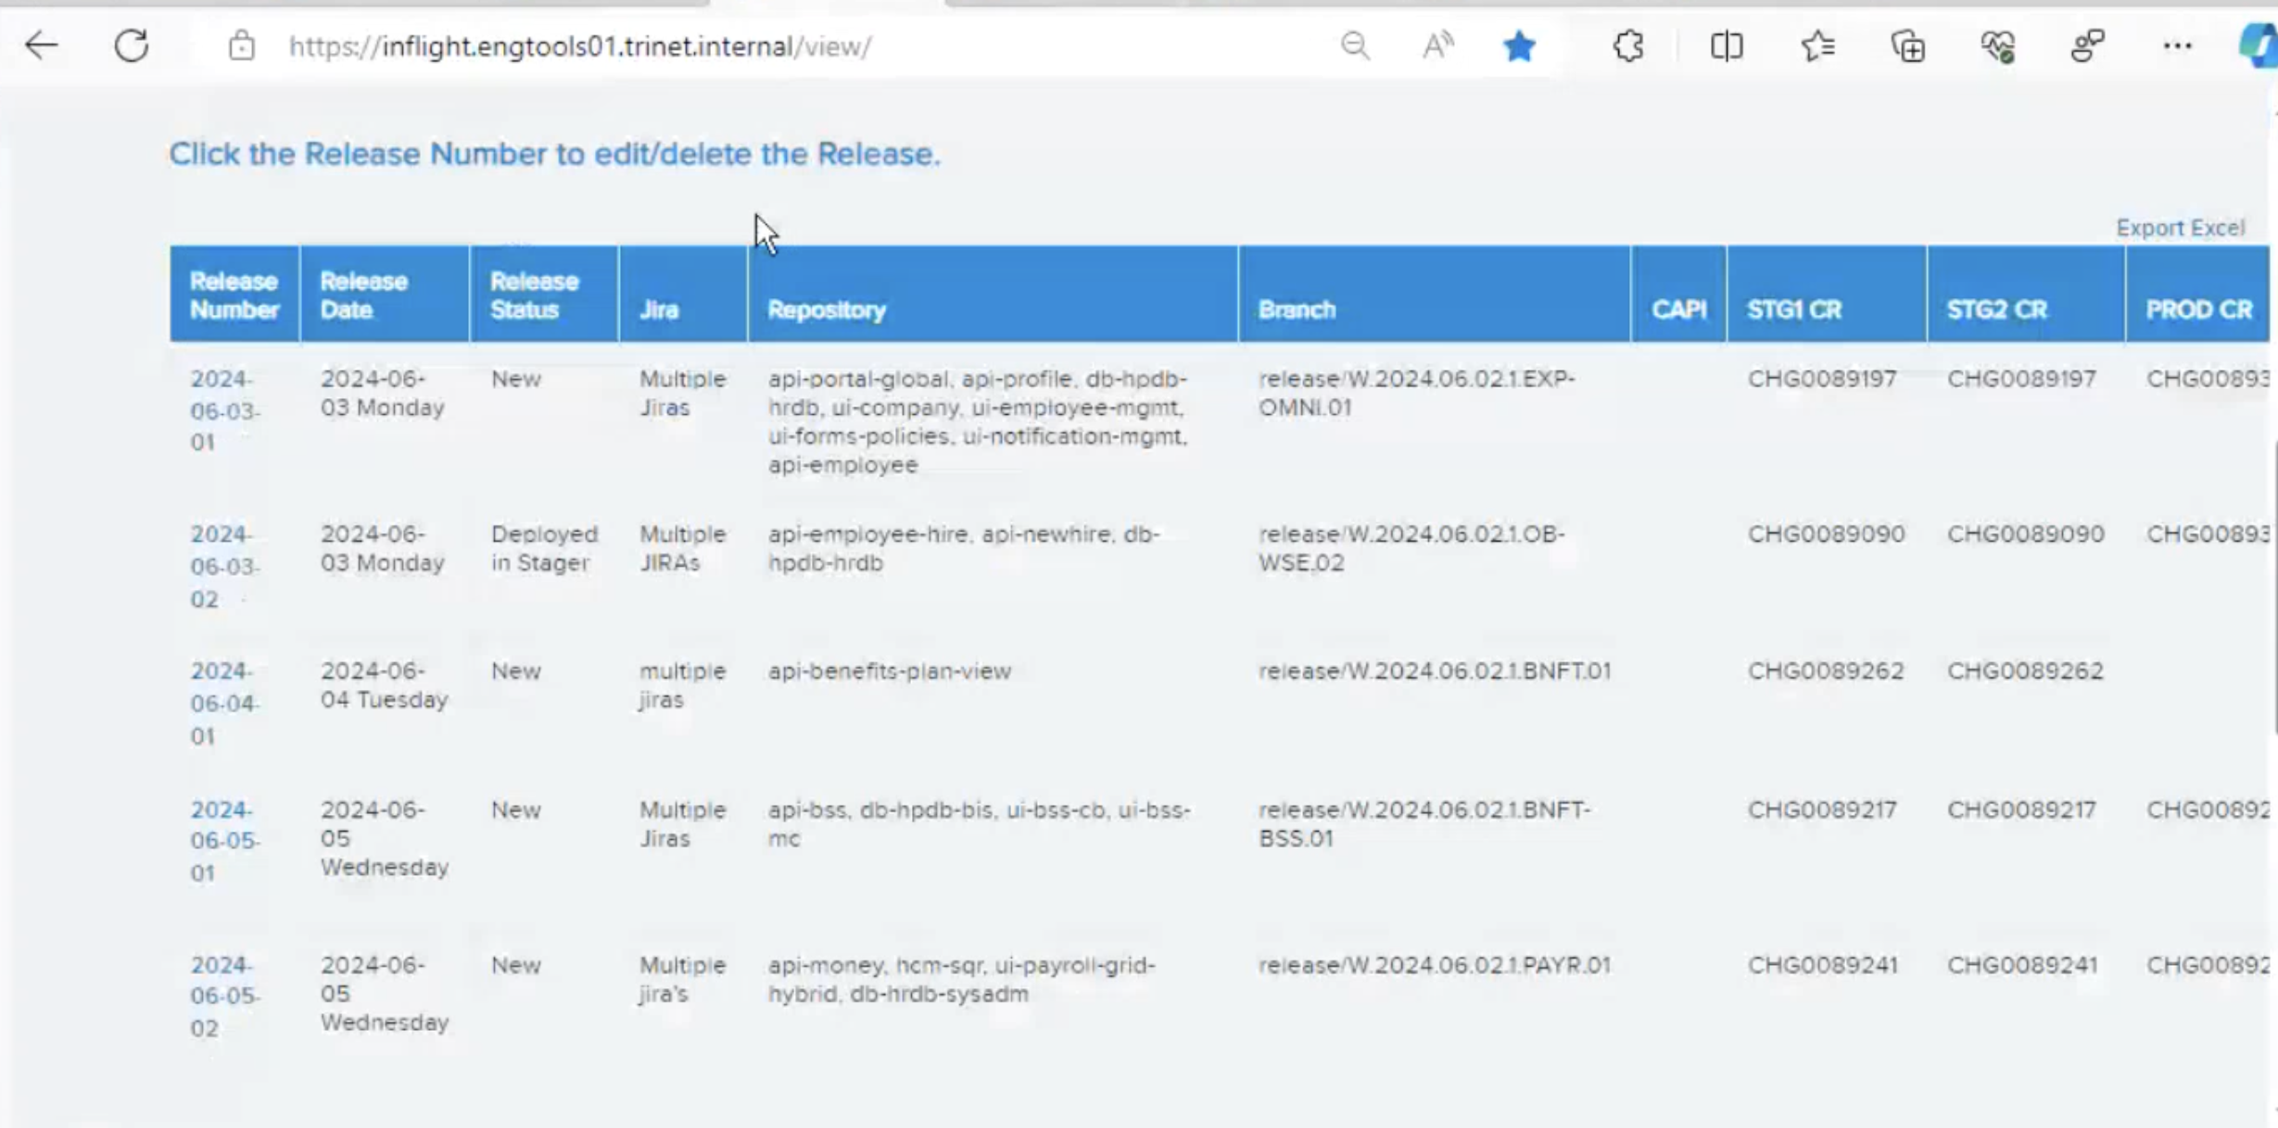

* Then we need to update them in CCB approved page in the confluence (generally these are done by shift C).

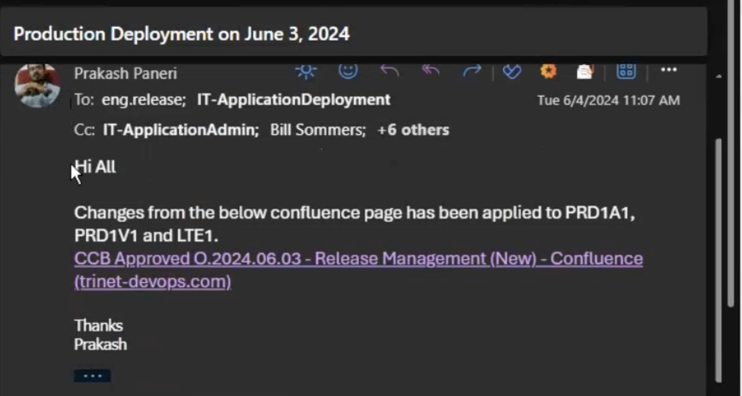

* CCB approved page is prepared prior a day for planning for next day merges by the release engineering team.

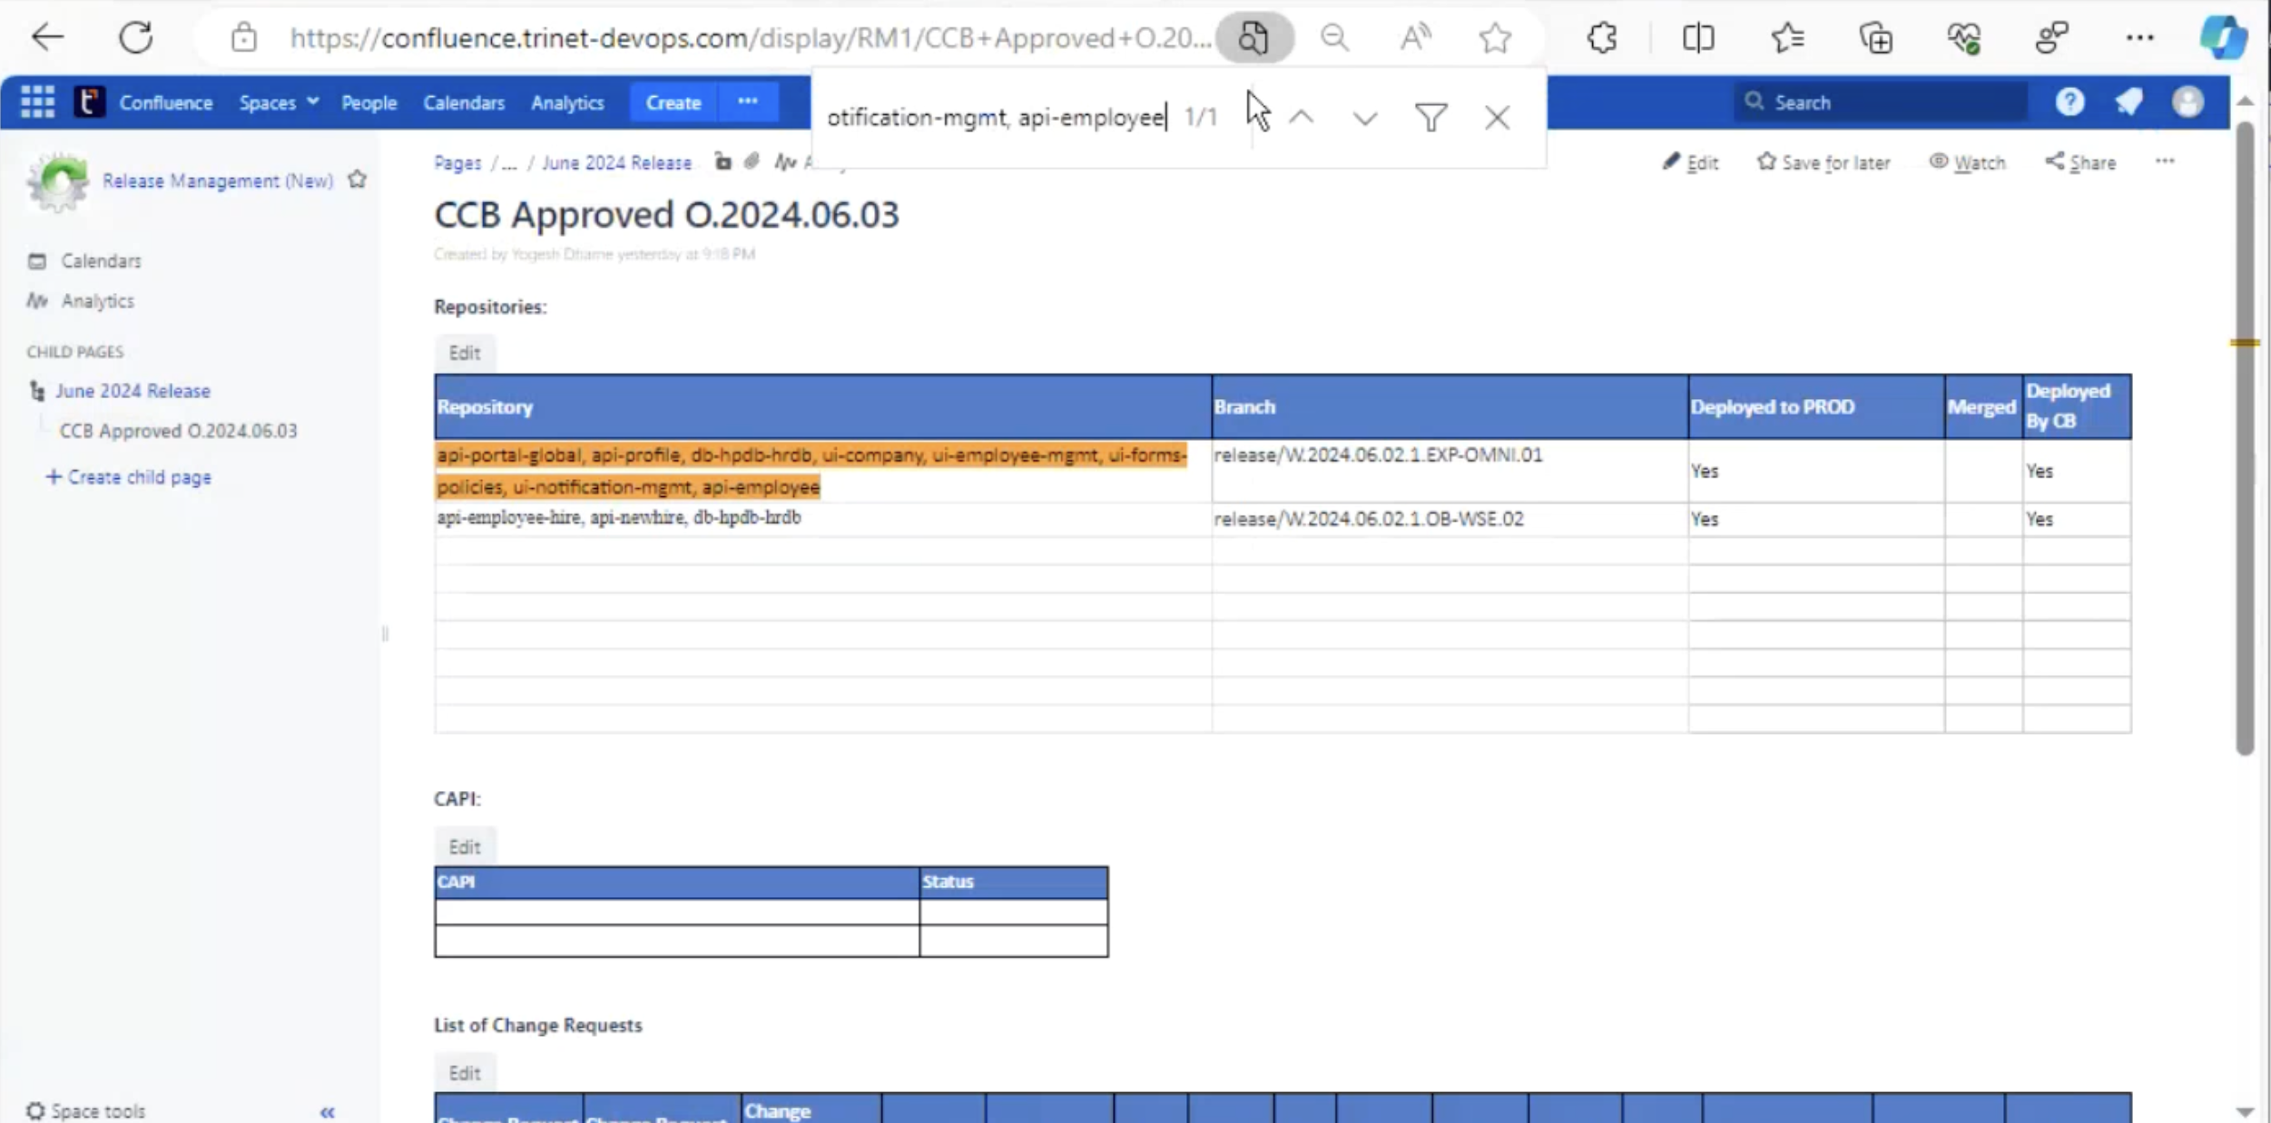

* For merging: Firstly, we need to check the branch name and repos in inflight page and mail from developer then we can proceed further to run the Jenkins job.
* Go to Jenkins Job and merge branch job there mention the branch name and repo’s and run the job if the job runs successfully then update the Jenkins job build image in email.

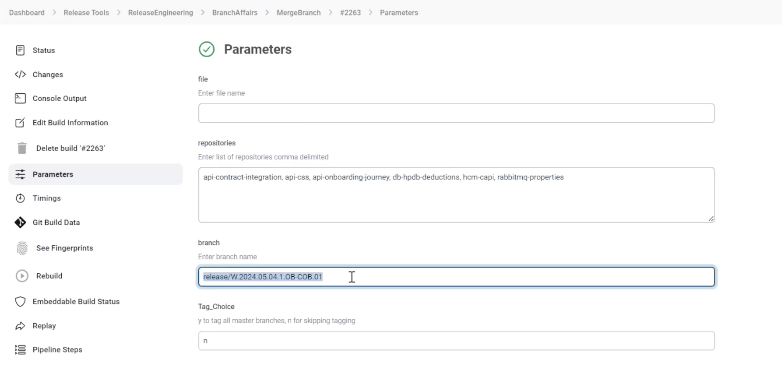

* Dashboard --- ReleaseEngineering --- BranchAffairs --- MergeBranch

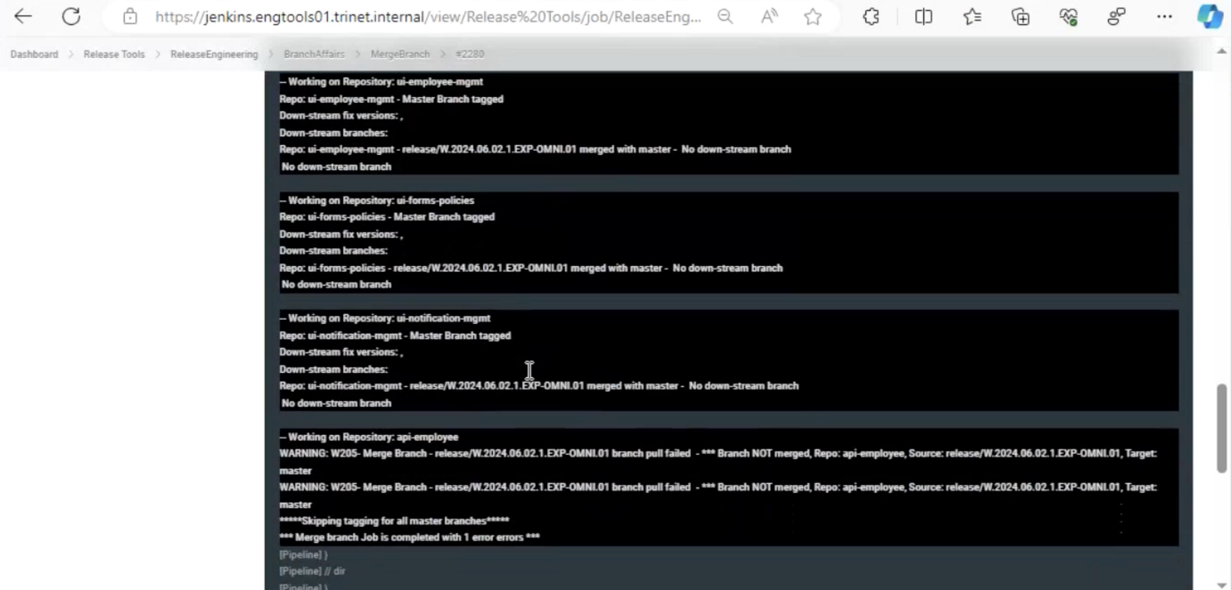

* We need to Update Merge to production is done successfully or not. If successfully completed then update Yes or not completed then update No.

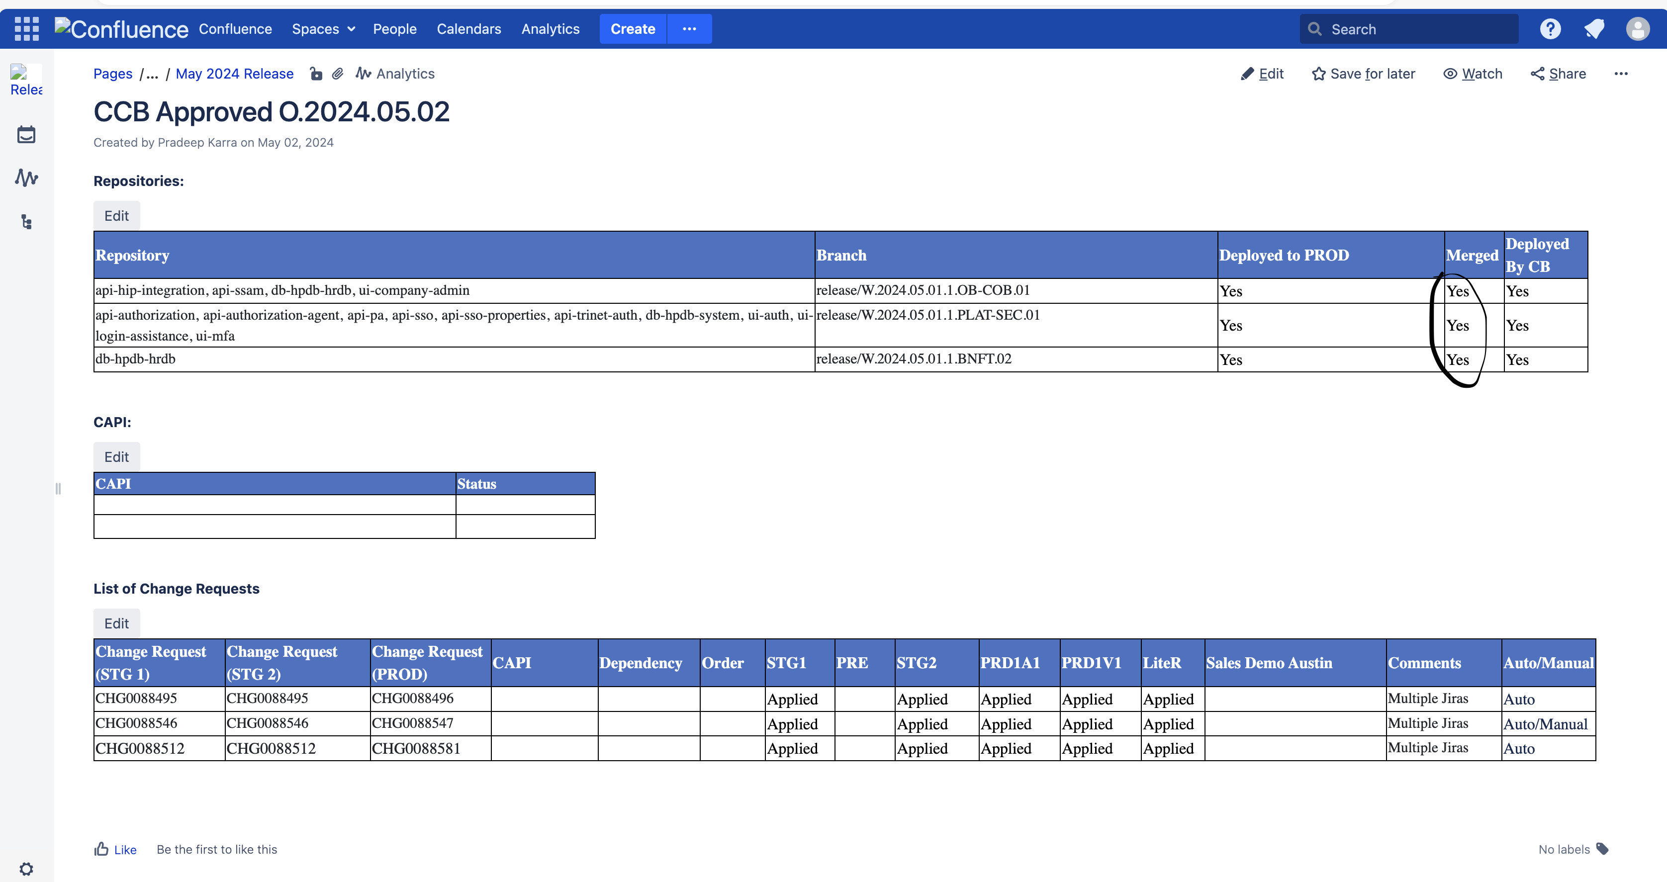

* After We need to send the email like below format.

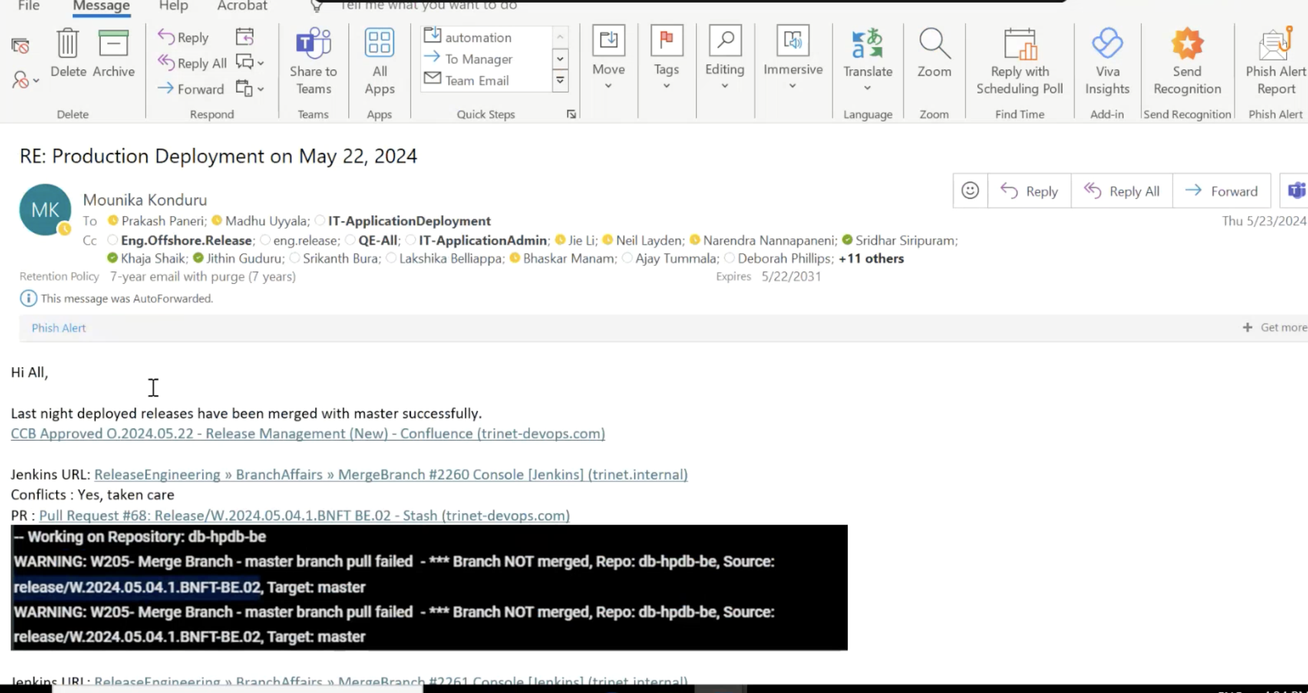

* If any error occurs in the Jenkins merge job build then navigate to stash(bitbucket) and then search for the repo in which we have error (job failure), then create a pull request & mention the source as branch name and destination as master then raise PR.
* General errors while performing merging of CR:
* Branch doesn’t exist:

Like any repo missing in the job, we run in this case we need to report back to developer either repo is missing, or branch might be deleted after checking in the bitbucket.

* Pom.xml error:

When we run the Jenkins job, we encounter sometimes pom.xml error, in this case we need to manually update pom.xml by working on the repo in virtual server and editing pom.xml (removing heads and tails from the file) and committing the code again, then raising for pull request manually

## **10. Pull Request Merge**

Pull request for merging of any branch when the repos are not in sync

RE team raises issue for developers when we find any repo sync issue and then developers work on it and they take care of sync issue and then comes for RE for merging

In this case we need to go for URL and check if everything is good we can merge directly and ask them to go for QE deployment

Merge conflict generally occurs when the branch doesn’t have updated code with the upcoming release.

Open the stash and check the URL whether it has merge conflicts if it has merge conflicts then they need to be resolved manually.

2 scenarios. **Never merge PR with conflicts for other code. Merge only if pom.xml**

1. Without conflicts

a) Direct merge option

b) Even after approving u can see 1 issue preventing. Copy paster error

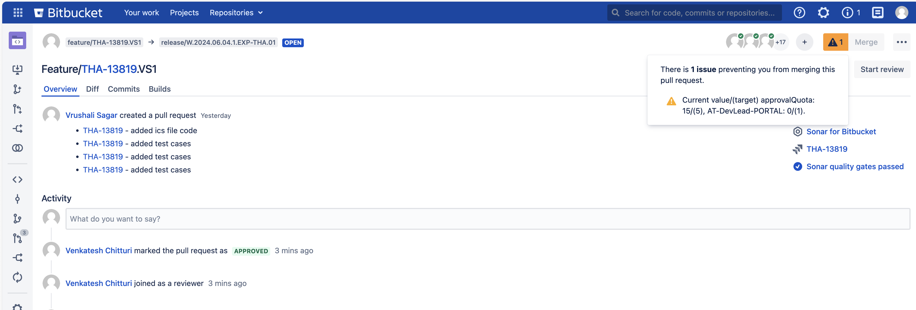

Here we don’t have any conflicts so we can merge directly and here there is a dependency for approval from other team so we need to inform dev team to get it approved from their end.

2. With conflicts

With conflicts is followed as below:

Here there is error in pom.xml and merging too so we need to merge request manually

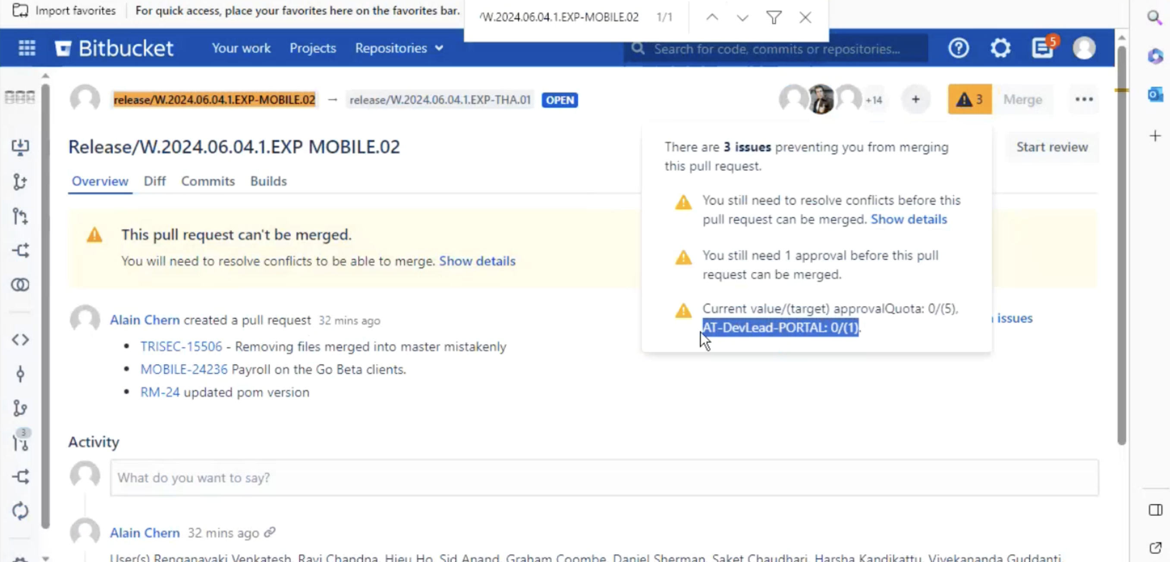

Go to terminal

Create a folder Merging,

cd Merging

ll

rm -rf “any repos found” (the created folder should be empty to avoid conflicts)

git config –edit –global (set your credentials here if already set check once)

git clone “url”(the repo which we want to sort out the merging)

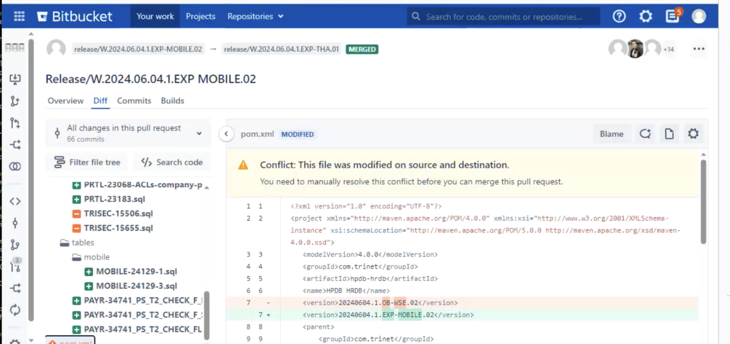

release/W.2024.06.04.1.EXP-THA.01 – destination branch, release/W.2024.06.04.1.EXP-MOBILE.02 – source branch

git checkout “destination branch”

git pull origin “source branch”

if we have pom.xml issue we need to fix it if other than that we need to revert to developer

vi pom.xml

remove head tail in the xml and save

git add .

git commit -m “commit id”

git push origin “destination branch”



After successful push we get the stash page as merged.

sometimes we cant see build triggering in the repo for the release branch then we need to run scan multiple branch and see for its build.

Follow below process. Check if latest build triggered & ask them to go for QE

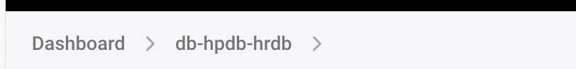

This is the repo which is reported to be not in sync so wee need to navigate to this repo and then go for release branch as below

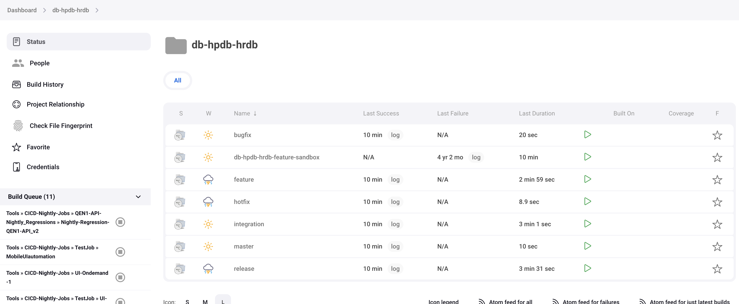

If the build is not triggered then we need to run scan multibranch pipeline now

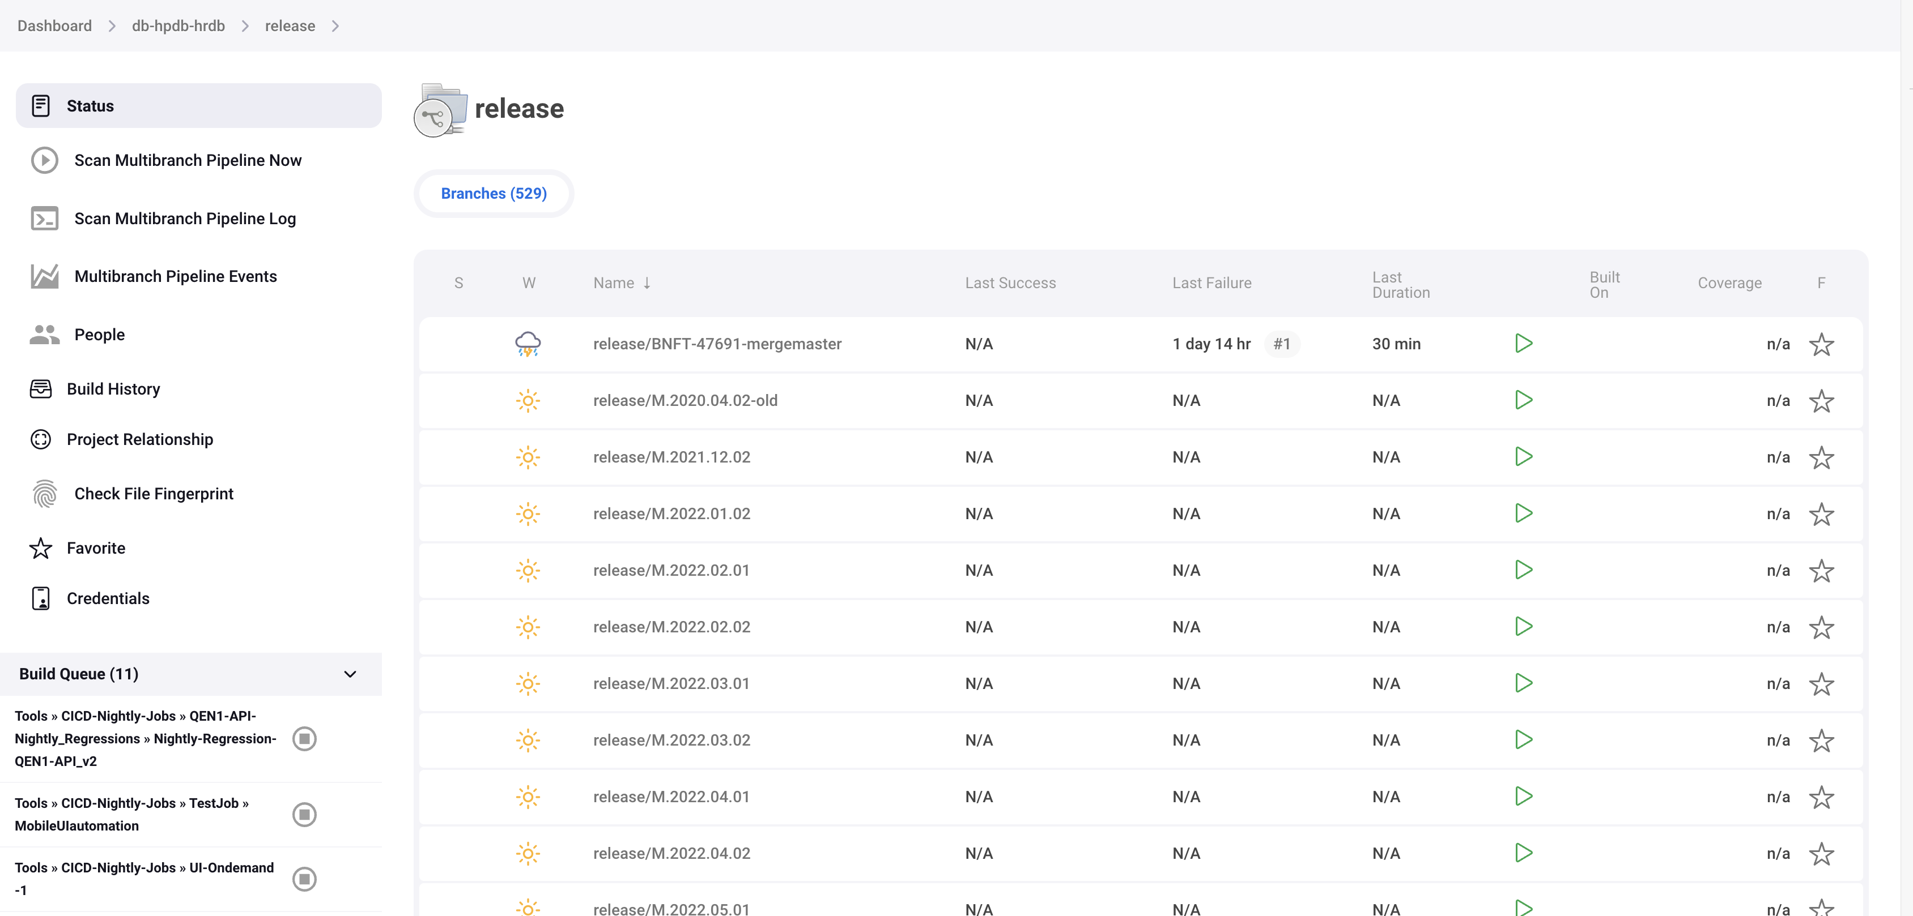

This will trigger the pending merged job and our job gets triggered we can check by giving branch name (release/W.2024.06.04.1.EXP-THA.01)

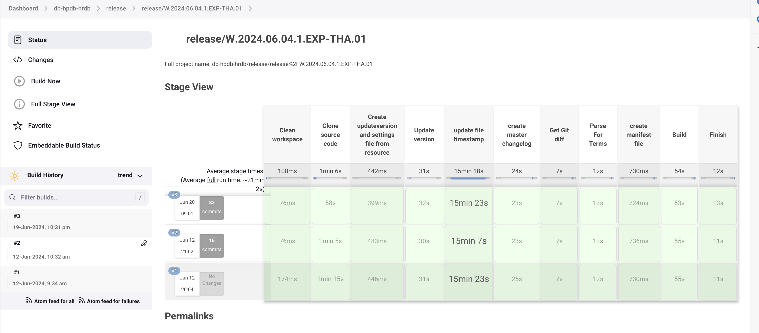

Here the build gets trigged, once it is done we should inform developers to go for QE deployment through mail.

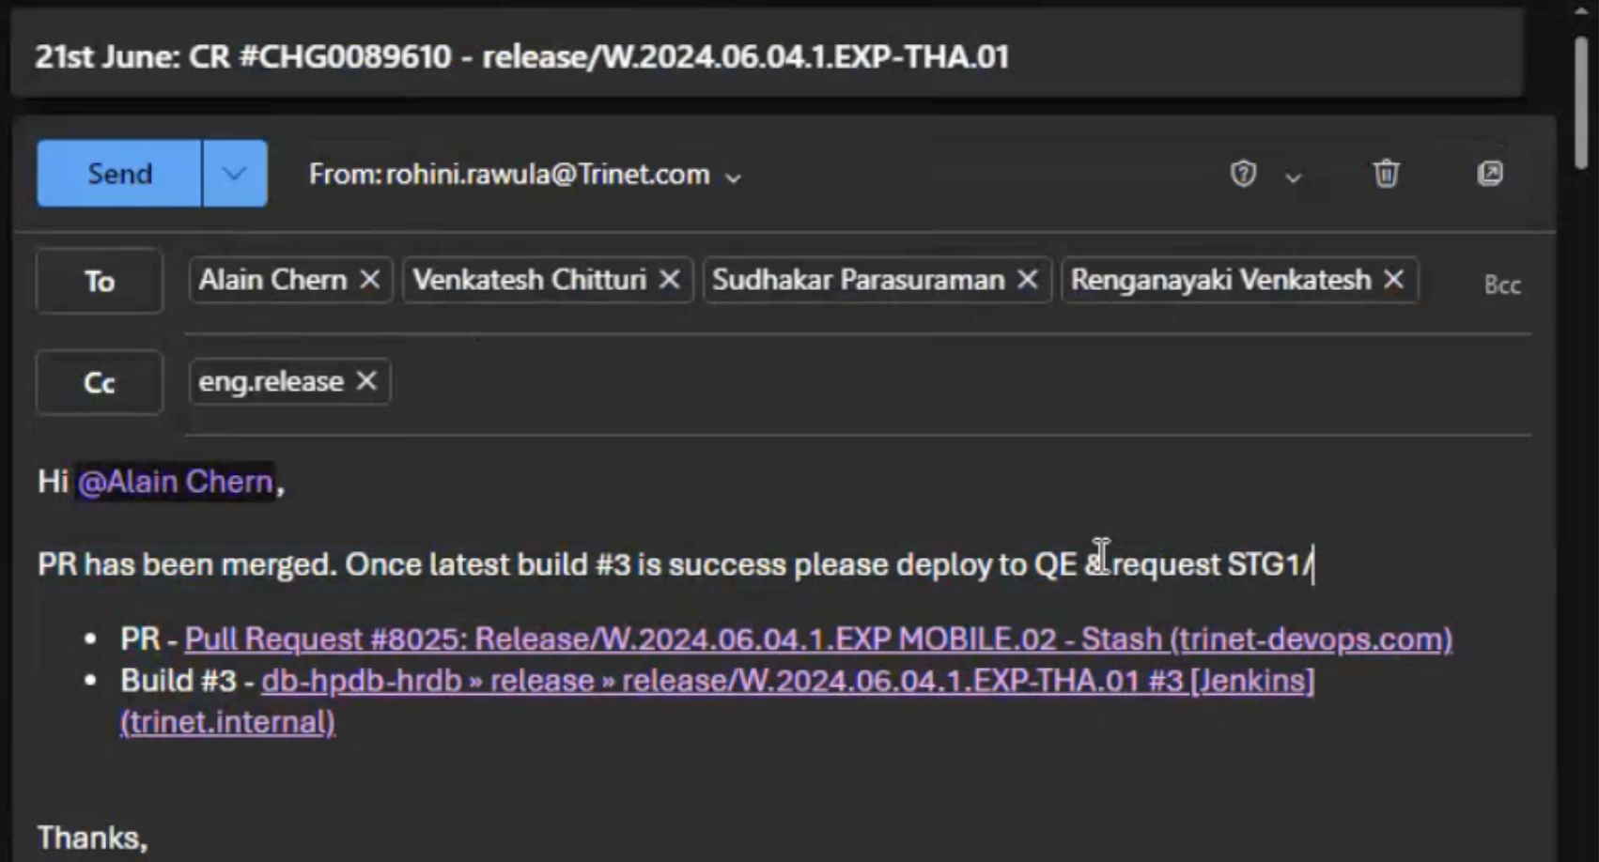

## **11. Release Engineering Daily URL’S**

Inflight backup page url: <https://confluence.trinetdevops.com/pages/viewpage.action?spaceKey=RM1&title=120+-+Inflight+release+page+backup>

Inflight page: [Inflight Page (trinet.internal)](https://inflight.engtools01.trinet.internal/view/)

Compare Braches: [150 - Compare release code in inflight release with master branch - Release Management (New) - Confluence (trinet-devops.com)](https://confluence.trinet-devops.com/display/RM1/150+-+Compare+release+code+in+inflight+release+with+master+branch)

[157 - Monitoring the releases in Inflight page - Release Management (New) - Confluence (trinet-devops.com)](https://confluence.trinet-devops.com/pages/viewpage.action?spaceKey=RM1&title=157+-+Monitoring+the+releases+in+Inflight+page)

[155 - Production CR review - Release Management (New) - Confluence (trinet-devops.com)](https://confluence.trinet-devops.com/display/RM1/155+-+Production+CR+review)

Weekly CCB report:

[Monthly Release - Release Management (New) - Confluence (trinet-devops.com)](https://confluence.trinet-devops.com/display/RM1/Monthly+Release)

Example for June month releases

[June 2024 Release - Release Management (New) - Confluence (trinet-devops.com)](https://confluence.trinet-devops.com/display/RM1/June+2024+Release)

Jenkins job for creating weekly release number

[Tools » Create-Branch-Weekly-with-Weekly-seq-num #6700 [Jenkins] (trinet.internal)](https://jenkins.engtools01.trinet.internal/job/Tools/job/Create-Branch-Weekly-with-Weekly-seq-num/6700/)

Jenkins weekly build report confluence page (KPI)

[Weekly Report 2024-06-01 to 2024-06-08 - Release Management (New) - Confluence (trinet-devops.com)](https://confluence.trinet-devops.com/display/RM1/Weekly+Report+2024-06-01+to+2024-06-08)

Jenkins job to create build analysis report

[ReleaseEngineering » Jenkins_Build_Analysis_Report #130 [Jenkins] (trinet.internal)](https://jenkins.engtools01.trinet.internal/job/ReleaseEngineering/job/Jenkins_Build_Analysis_Report/130/)

Release team onshore reach for issue resolving url:

[Release Team - On-shore on-call schedule - Release Management (New) - Confluence (trinet-devops.com)](https://confluence.trinet-devops.com/pages/viewpage.action?spaceKey=RM1&title=Release+Team+-+On-shore+on-call+schedule)